# IMPROVED LEARNING MANAGEMENT SYSTEM

Graduation Project

*Presented by:*

| *Marwan Tamer Galal* | *20200508* |
| --- | --- |
| *Abdelrahman Mohamed Ahmed* | *20200318* |
| *Ahmed Mohammed Fayek* | *20200043* |
| *David Nael Nady* | *20200172* |
| *Mohamed Mahmoud Mohamed* | *20200474* |

*Under the supervision of*

*Assoc. Prof. Iman Helal*

# 

# Abstract

# 

In response to the growing need for better Learning Management System (LMS) platforms, we're embarking on a project with a simple mission: to create a user-friendly, highly customizable e-learning platform that benefits students, educators, and administrators alike.

For students, it will serve as a one-stop repository for all their study materials and tools, designed to make their learning journey as smooth as possible. For educators, it will provide a seamless teaching environment, fostering communication and personalisation. Administrators will gain analytical insights for informed decision-making.

Our project's scope covers core areas, ensuring accessibility and usability for students, efficient course management for teachers, and streamlined data retrieval for administrators. We won't be venturing into more complex features like AI assistance or video conferencing due to resource constraints.

We're adopting an agile approach, allowing us to adapt. We value collaboration and continuous improvement, bringing us closer to our goal.

This report includes chapters on market analysis, project details, system design, testing, results, and future possibilities. You can also find additional reports in the appendices for a deeper dive into our project journey.

Keywords: Learning Management System , LMS, Course Management, XAPI.

# 

# Table Of Contents

# 

IMPROVED LEARNING MANAGEMENT SYSTEM 1

Abstract 2

Table Of Contents 3

List of Tables 5

List of Figures 6

List of Acronyms 7

Chapter 1: Introduction of the Project and its Vision. 8

1.1 Background and Motivation 8

1.2 Problem Statement 8

1.3 Objectives 8

1.4 Project Scope and Limitations 9

1.5 Project Initial Timeline and Workload 9

1.6 Project Methodology 9

1.7 Project Report Outline 9

1.8 Project Timeline 10

1.9 Work Distribution 11

Chapter 2: Market and Literature Survey 12

2.1 Competitors 12

■ Blackboard: 12

■ Acadox: 12

■ Thinqi: 12

■ Google Classroom: 12

■ Ain Shams: 12

2.2 Competitor Analysis 13

13

2.3 SWOT Analysis 14

2.4 Features 15

■ The key features: 15

■ Leading principals: 15

Chapter 3: Analysis 16

3.1 Data Gathering 16

3.2 Survey Structure 16

3.3 Analysis Steps 16

3.4 Survey Results 19

3.5 Project Preliminary Requirements 21

■ Must Have Features: 21

■ Should Have Features: 22

■ Nice to Have Features: 22

■ Functional requirements 23

■ Non-functional 24

3.6 Use Case Diagram 25

3.7 Use Case Descriptions 27

Chapter 4: Design 62

4.1 Architecture 62

4.2 BPMN Diagrams 63

Appendix 65

A.Competitor Analysis: 65

B. Student Survey: 65

C. Teacher Survey: 65

D. Responses and data analysis: 65

E. Students Survey Statistics Results: 65

a. Blackboard Learn: 68

b. Google Classroom Users 72

c. Microsoft Teams Users 75

F. Initial Requirements: 81

G. Use Cases Brief 87

# 

# List of Tables

# 

Table1: Competitor Analysis12

Table2: Use Case Description 1 27

Table3: Use Case Description 2 28

Table4: Use Case Description 3 29

Table5: Use Case Description 4 30

Table6: Use Case Description 5 31

Table7: Use Case Description 7 32

Table8: Use Case Description 8 33

Table9: Use Case Description 9 34

Table10: Use Case Description 10 35

Table11: Use Case Description 11 36

Table12: Use Case Description 12 37

Table13: Use Case Description 13 38

Table14: Use Case Description 14 39

Table15: Use Case Description 15 40

Table16: Use Case Description 16 41

Table17: Use Case Description 17 42

Table18: Use Case Description 18 43

Table19: Use Case Description 19 44

Table20: Use Case Description 20 45

Table21: Use Case Description 21 46

Table22: Use Case Description 22 47

Table23: Use Case Description 23 48

Table24: Use Case Description 24 49

Table25: Use Case Description 25 50

Table26: Use Case Description 26 51

Table27: Use Case Description 27 52

# 

# List of Figures

# 

Figure1: Survey Analysis Steps 18

Figure2: Survey Faculties Chart 19

Figure3: Survey Universites Chart 19

Figure 4: Survey Student Year Chart 19

Figure5: Survey LMS Preference Chart 20

Figure6: Survey LMS Usage Comparison 21

Figure7: Use Case Diagram 26

# 

# List of Acronyms

| **Acronym** | **Stands for** |
| --- | --- |
| LMS | Learning Management System |
| XAPI | Experience API |
| AWS | Amazon Web Services |
| WCAG | Web Consortium Accessibility Guidelines |
| UI | User Interface |
| UX | User Experience |
|  |  |
|  |  |
|  |  |
|  |  |
|  |  |
|  |  |
|  |  |
|  |  |
|  |  |
|  |  |

# 

# Chapter 1: Introduction of the Project and its Vision.

## 1.1 Background and Motivation

Hybrid learning has become increasingly important since the COVID-19 pandemic began in 2020. To meet this new demand in the market, numerous platforms and applications have emerged to cater to educational institutions, individual trainers, and software companies that create platforms for specific fields of education. Each platform has its unique advantages and disadvantages, but most suffer from issues such as low usability, difficult maintenance, and a focus on specific types of education. Our team recognizes the need for a better platform and has decided to develop one to meet the needs of learners and educators.

## 1.2 Problem Statement

The present problem is the lack of LMS and proper LMS usage in the Egyptian market which hinders the progress and user experience of many learners which opens the way for the creation of new LMSs catered to the Egyptian/Arabic population.

## 1.3 Objectives

Our team's objective and vision is to create an e-learning platform that provides a perfect learning environment for students, teaching staff, and management. We aim to create a platform that is easy to use, and customizable and provides all the necessary tools for learners and educators to succeed.

* For students, we envision a platform that acts as their personal repository containing all their studying material and all the tools they need to succeed in their specific field of study.
* For educators, we envision a platform that provides a seamless environment for communication, monitoring, connecting with students, and delivering personalized education. Our platform will allow them to create their personalized classroom with every tool they need to provide the best possible education for their students.
* For management, we aim to provide an analytical platform that enables them to review and evaluate their teaching staff and courses, providing a data-driven approach to decision-making.

## 1.4 Project Scope and Limitations

The Current agreed scope is an LMS that covers students' accessibility to content and their user experience, covers teachers' needs for easy-to-modify and manage live courses, and lastly covers the administration's needs for an easy-to-use interface to pull relevant data and analyze it.

All other subjects that don’t directly fall under those 3 categories are outside the scope of starting the project, for example, customized learning paths for each student, AI assistance, and video conferencing.

Some limitations of this project are its system requirements as LMSs need optimized services to allow thousands of students to connect at the same time, thus some hardware limitations may be specified depending on the chosen architecture.

## 1.5 Project Initial Timeline and Workload

## 1.6 Project Methodology

The chosen Methodology will be agile. Though we have a clear end goal, we still require more research and testing to realize the actual structure and architecture which means that some features may be added and removed as necessary, so the Agile methodology will allow us more flexibility to review and change goals, scope and design as necessarily, its greatest benefit will be the teams' ability to cross work on different tasks to ensure continuous improvement and progress towards the end goal.

## 1.7 Project Report Outline

For this report we followed the report guidelines. Chapter 2 is concerned with market analysis and literature survey. Chapter 3 is concerned with the project analysis where we conducted a survey to output the main features and their prospective functional and non-functional requirements. Chapter 4 is concerned with the design and the architecture of the system, detailing class diagrams, ERD models, BPM models, etc. Chapter 5 is concerned with testing and evaluating the system and its features. Chapter 6 is the last chapter focusing on the results of the project and possible future works. Lastly, the Appendix which contains detailed copies of the reports used during this project development or refers to the appendix Folder which contains the actual reports.

*Table 1 Project Timeline*

## 1.8 Project Timeline

| 8/23 | 9/23 | 10/23 | 11/23 | 12/23 | 1/24 | 2/24 | 3/24 | 4/24 | 5/24 |
| --- | --- | --- | --- | --- | --- | --- | --- | --- | --- |
| **Requirement Gathering**:  Proposal Writing.  Proposal approval.  survey creation.  **Analysis**:  Competitor analysis.  SWOT analysis | **Documentation started.**  **Requirement gathering:**  Collecting survey responses.  **Analysis:**  Analysing survey.  High-level features system recruitment. | **Documentation cont**.  **Analysis:**  Functional and non-functional requirements,  Use case Diagrams and descriptions.  **Design:**  BPMN models,  high level architecture.  Preliminary dataflows. | **Documentation cont.**  **Analysis:**  Full UI/UX analysis.  Detailed user personas and journeys.  **Design:**  **Class Diagram.**  ERD Diagram.  sequence Diagram.  Preliminary wireframes. | **Documentation cont**.  Finished UI Frames to use as references.  Revising the Analysis and Design plans and resources.  Initial Preparations for Implementation (API Endpoints guidelines, Mock data for testing, UI guidelines and rules) | **Documentation cont**.  Halting due to first-semester finals.  Only small auditions and fine-tuning | **Documentation cont.**  **Implementation:**  Mobile app  Website  Database  Server | **Documentation cont.**  **Implementation:**  Mobile app  Server  Website  Database  **Testing:**  initial processes test cases  test suite creations | **Documentation cont.**  **Implementation:**  Server  Security  **Testing:**  Increase testing cases and security testing. | **Documentation cont.**  **Testing:**  Running all regression checks.  Fixing any remaining bugs.  Polishing UI |

## 

## 1.9 Work Distribution

**Marwan:**

* Coordination of Work.
* Documentation writing and maintenance.
* System Features and Requirements.
* System Specification.
* Database System.
* Backend Servers.
* Testing.

**Abd-Elrahman:**

* Survey Creation and Its Analysis.
* Documentation Editing.
* System Features and Requirements.
* UX research.
* UI Frames.
* GP Presentation.

**Ahmed:**

* UseCase Descriptions.
* BPMN Diagrams.
* Class and ERD Diagrams.
* Mobile Application.
* Backend Server

**David:**

* Functional and non-functional requirements,
* UseCase Descriptions.
* BPMN Diagrams.
* Sequence Diagrams.
* Mobile Application.

**Mohamed:**

* Business plan.
* UseCase Diagrams.
* FrontEnd Application.
* Testing.

## 

# Chapter 2: Market and Literature Survey

## 2.1 Competitors

In this section, we will discuss the advantages and disadvantages of some of the most popular e-learning platforms currently available. For the full competitors' Analysis please refer to the index. These platforms include:

### Blackboard:

Blackboard is a very popular e-learning platform that offers a variety of features, including communication tools, course management, and content management. Its advantages include its flexibility and its ability to integrate with various other educational tools. It is extremely versatile due to its many features like video streaming and a mobile app available too. However, its disadvantages include its complexity and the steep learning curve required to use it effectively due to how complicated the interface may be to inexperienced students alongside connection issues that may happen in areas with poor internet connections.

### Acadox:

Acadox is a learning management system that offers features such as course management, assignment submission, and student attendance tracking. Its advantages include its high ease of use and its flexibility. However, its disadvantages include its limited customisation options, lack of advanced features and proper marketing with big institutions.

### Thinqi:

Thinqi is a cloud-based e-learning platform that offers features such as course creation, collaboration tools, and learner management. Its advantages include its user-friendly interface and its ability to be customized to fit the needs of specific users. However, its disadvantages include its lack of advanced features and its limited reporting capabilities.

### Google Classroom:

Google Classroom is a free e-learning platform that offers features such as course management, assignment creation, and student progress tracking. Its advantages include its ease of use and its integration with other Google tools. However, its disadvantages include its limited customisation options and its lack of advanced features though those disadvantages can be seen as targeting a specific customer profile who needs a simple and lightweight educational platform.

### Ain Shams:

Ain Shams is a popular e-learning platform used by ِAin shams university. Its advantages include its ease of use and its flexibility. However, its disadvantages include its limited customisation options and its lack of advanced features.

## 2.2 Competitor Analysis

## 

## 

## 2.3 SWOT Analysis

* + - Strengths:
* User-centric design, with a focus on providing an intuitive and easy-to-use platform for learners, educators, and management.
* Advanced analytics and reporting capabilities that enable data-driven decision-making.
* Support for mobile learning and accessibility features, ensuring that all learners have equal access to the content.
* Personalized learning paths and adaptive assessments, providing tailored learning experiences for individual student needs and abilities.
  + - Weaknesses:
* Lack of brand recognition and reputation, which may make it challenging to attract users in a crowded market.
* The development of advanced features and analytics capabilities may require a significant investment of resources.
* The platform may require ongoing maintenance and updates to ensure that it remains relevant and up-to-date.
  + - Opportunities:
* The growing demand for e-learning platforms due to the COVID-19 pandemic and the increasing importance of online learning.
* The potential to partner with educational institutions and organizations to promote the platform and attract users.
* The potential to expand the platform to include additional features or support for other types of education.
  + - Threats:
* Intense competition from established e-learning platforms that have a strong brand and reputation.
* The risk of security breaches or data loss, which could undermine user confidence in the platform.
* Regulatory and compliance issues that may arise when handling sensitive student data.

## 

## 2.4 Features

Our team aims to create a platform that provides a better user experience and better maintenance and monitoring for educators. We will focus on addressing the shortcomings of other mainstream platforms. A detailed version based on the additional information gained from the survey can be found in Chapter 3 Section 5

### The key features:

* Acting as a material repository for students
* Conducting quizzes and tracking grades
* Providing easy-to-use tools for educators to communicate with students and track their progress.
* Advanced analytics and reporting capabilities that provide insight into student performance, course effectiveness, and learning outcomes.
* Support for mobile learning, allowing students to access content and interact with their instructors on their smartphones and tablets.
* Accessibility features, such as closed captioning, text-to-speech, and other assistive technologies to ensure that all learners have equal access to the content.
* Personalized learning paths and adaptive assessments that provide tailored learning experiences based on individual student needs and abilities.

### Leading principals:

* + - User-centric design:

Our team is committed to creating a platform that is intuitive, easy to use, and meets the needs of our users. We will prioritize user feedback throughout the development process to ensure that our platform is tailored to the needs of modern learners and educators.

* + - Analytics and reporting:

Our platform will provide advanced analytics and reporting capabilities that provide insight into student performance, course effectiveness, and learning outcomes. This will enable educators and management to make data-driven decisions and continuously improve the learning experience.

# Chapter 3: Analysis

## 3.1 Data Gathering

Our vision with this project is to create an LMS that provides an easy and competent environment for students, making them not need that many external tools, for teachers to ease their experience and allows them to provide the most value for students with the least effort and for administrators to easily keep track of the courses, performances and efficiency of their staff. Thus to help direct our project and provide more concrete steps towards those goals, we conducted 2 surveys with the aim of asking students and teachers about their experiences with LMS, their preferred one, the issues they face, and the features they wish to see.

With that in mind, given how we want both the needs of less-experienced stakeholders like our students and extremely experienced stakeholders like teaching staff, we opted to create 2 different surveys. Though both have the same goal, the student version is more quantitative with some supplementary qualitative questions seeking to collect as much data as possible with most questions being Multiple Option Questions and 5-step Likert scale questions starting from 1 (Strongly disagree) till 5 (Strongly Agree). EX: “on a scale from 1 to 5. Please rate this” which allows us to analyse their responses and weight them to notice any inconsistencies or repeated sentiments. For the teachers, we tried to focus on qualitative questions given they are both stakeholders we are less familiar with, given we are students ourselves, and due to their years of experience they would have better awareness and expertise dealing with LMS.

## 3.2 Survey Structure

For ease of use, we chose a commonly used form creation tool which is Google Forms and started creating our questionnaire using scale questions, multiple choice and open-ended questions. Due to having a good amount of foreign students at Cairo University, we decided to include an Arabic or English choice for the students to make sure it can be accessible and easy for students who are still learning Arabic. For a full detailed list of all the questions please refer to the appendix.

## 3.3 Analysis Steps

To process the data we received and present them into a proper summary report we used an Excel sheet as it is the format Google form outputs. We got the collected data and proceeded to rearrange it into the staging sheet. We used this step to format the responses in a more clear way and prepare for the analysis stage. For the sake of summarisation, we opted to categorize the responses and analyse the responses for the top 3 LMSs which most people have experience using because it implies that those 3 will also have better-educated responses and suggestions.

As pointed out before the student survey is mostly quantitative questions so analysis of their responses took the form of sorting the numerical data for questions with multiple options getting means for scale questions and then visualizing them using charts to show how each option compares to the others and point out clear user preferences and/or characteristics.

For the qualitative questions, we decided to categorize them based on important elements to the users like speed, ease of use, functionality, etc. And picked the most recurring requests in our report for each major LMS.

## 

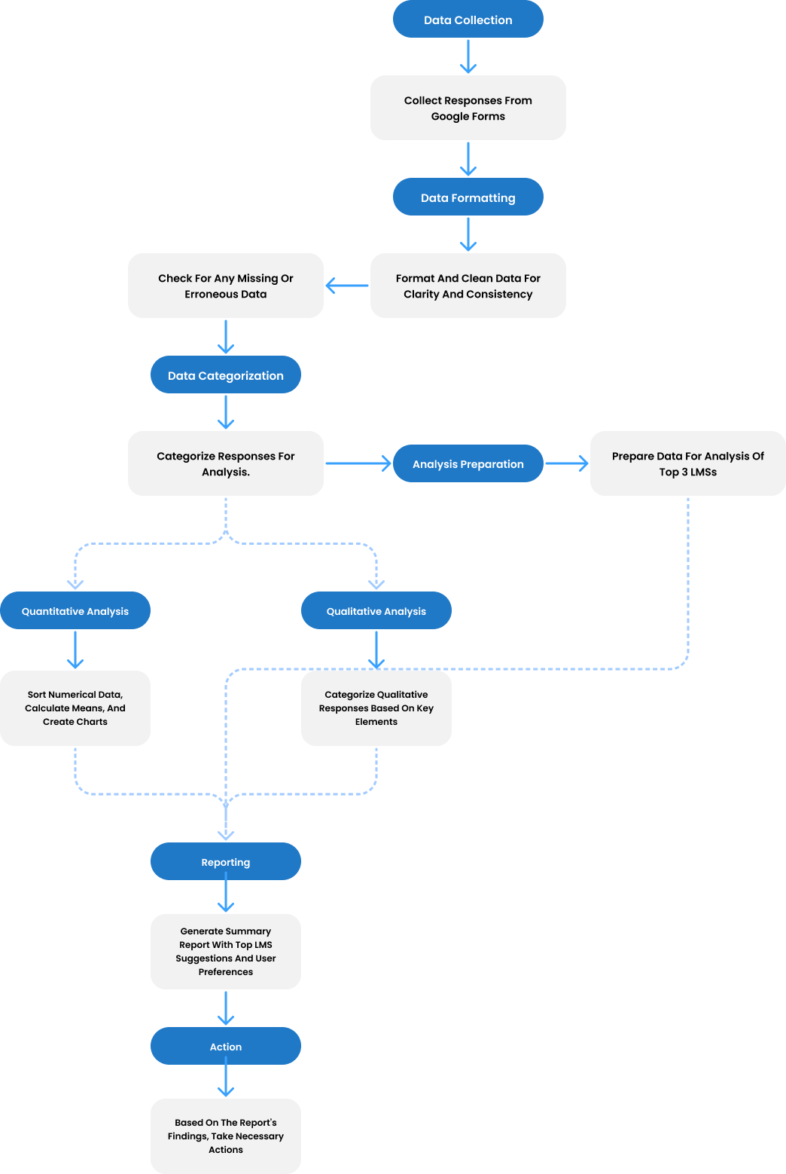

## 3.4 Survey Results

Our survey collected 98 responses from students and all extra details can be found in the full report in the appendix. The students were from various faculties though most of them were from Cairo University and in engineering or computer science faculties. Most of them are in their fourth year, in computer science and engineering Faculties, and have used an LMS before(95.6%) which is reflected in Figure 12 Survey Faculty Chart, Figure 11 Survey University Chart*,* and Figure 10 Survey University Year Chart

Though the sample size is small, some helpful insights can be gained from the quantitative results alone, as 56.3% said they use both mobile and Web apps and 6.3% rely fully on the LMS mobile app which points out the importance of having an accessible and easy to use mobile application.

The answers to question 8 on the students' survey (how often do you use the LMS) are a bit inconclusive as 40.5% of the respondents said they use it daily and 36.7% said they rarely use it which points out the variance of how students approach using an LMS and using external tools or other sources to study like YouTube.

But most important is the usage data on which LMS the students preferred here Figure 15 Survey Preferred LMS Chart. Which shows that Blackboard, Google Classroom, and Microsoft Teams are the top three choices for LMS.

On the top is the chart representing the percentages of which LMS the students preferred (Question 7) while below are the cumulative numbers of which LMS the students ever used (Question 6)

It is also crucial to point out a few major points that are derived from this data.

* Firstly, even though Microsoft Teams is not an LMS in the strictest terms, its features of organizing work, dashboards, sharing material and video streaming made it a very useful tool for students and teachers alike.
* Secondly, An interesting note to point out is that 100% of the respondents who chose Blackboard as their preferred LMS were all from Cairo University, adding The fact that most respondents are from Cairo University suggests that the current features of Blackboard are liked enough to warrant a second place even when no other student from another university chose Blackboard.
* Thirdly, This also warrants a deeper look into Google Classroom, as though compared to Blackboard it lacks a lot of the features that allow Blackboard to be an internationally recognized LMS, it is still preferred by many students.
* Lastly, following up on the previous point, even though we added other internationally recognized LMSs like Canvas and Moodle, barely anyone preferred them or even used them. This can be due to our limited respondents but it can also imply a lack of experiments with those LMS in higher education in Egypt.

Figure 14 Survey LMS Cumulative Usage Chart

For the teachers' survey sadly we only received 6 responses which is an inadequate number to do a proper data-driven analysis. However, given how most of the questions were qualitative, we can simply screen the responses manually instead of doing deep analysis and categorization.

By going through the responses some common points were made by the teaching staff on how important Ease of use, reusability, of course, issues caused by low bandwidth, sharing and organizing files easier, making quizzes and lastly video conferencing.

## 3.5 Project Preliminary Requirements

Per the previous Analysis results, we created a list of requirements/features that should be apparent and focused upon in the project design phases as they can be considered our initial goals and main features till further improvements and adaptations happen. For a full detailed list with explanations for each item please refer to the appendix. The list is split into 3 categories based on priority/importance/Ease of implementation, Those 3 categories.

* Must Have Features: Features that are crucial to the LMS and should not pose significant trouble implementing.
* Should Have Features: Features that include quality-of-life improvements or minor additions to the system as a whole and their implementation may need consideration in the design phase or are easy to implement.
* Nice To Have Features: Features that can benefit stakeholders but are not crucial and their implementation may be extremely complicated and/or require extreme hardware capabilities.

### Must Have Features:

* User Dashboard
* Tracking Course Progress
* Cloud Storage
* Multi-language support ability
* Communication Features
* User-Friendly and easy to navigate Interface
* Accessible interface
* Hot Keys/Quick Access to Tools
* Labels and Categorisation/Platform Organization
* Self-Enrollment with invitations or codes
* Create Courses
* Add Material/Reuse material from other courses
* Tasks/Assignments
* Writing/Post Editor page
* Quiz assignments
* Mobile App Availability
* Fast Performance
* Blog per Course

### Should Have Features:

* Dark Mode Option
* Youtube video Integration
* SCROM/Xapi/Interoperability Conformance
* Enhanced Search Tools
* Customizable Settings
* Direct File Downloads
* Tutorials
* Advanced (reply to, set reminders,etc) Notifications
* File Management System
* Integrated External Resources
* Assessment Tools (Scoring) /Teacher Dashboard
* Feedback Mechanisms
* In-depth Analytics

### Nice to Have Features:

* Live Meeting Functionality
* Personalized Learning Paths
* Collaborative Features/ Student teams and shared scores
* Auto-grading (Text recognition)

### Functional requirements

1. **User Authentication:**

User initiates registration by providing details and system validates.

User logs in using credentials or third-party accounts.

User resets the password if forgotten.

1. **User Actions:**

Students enrolled in courses, access content, and track progress.

Teacher creates/updates/reviews/deletes assignments, materials, quizzes, and courses.

1. **Platform Features:**

User uploads, downloads, and manages learning materials.

Users set preferences for language (Ar, En), accessibility (screen light, colour blind palette), and appearance (Font size, font format, dark/light modes).

1. **Course Management:**

Admin generates enrollment codes and controls courses.

Student self-enrolls using provided codes.

1. **User Settings:**

User updates profile, manages preferences, and data.

1. **Feedback and Assessment:**

Users provide feedback, ratings, and engage in assessments.

1. **Mobile App and Accessibility:**

Users access the platform via mobile app with optimized design.

User utilizes accessibility features.

1. **Admin Functions:**

Admin manages users, courses, platform, and configurations.

1. **Reports and Analytics:**

Admin reviews reports and analytics for decision-making.

1. **User Support and Maintenance:**

Admin supports users and oversees platform maintenance.

### Non-functional

**Usability**:

* **Accessibility**: Ensure compliance with accessibility standards (e.g., Web Consortium Accessibility Guidelines WCAG) to make the LMS usable for individuals with disabilities.
* **User Experience (UX**): Define guidelines for the overall user experience, such as intuitive navigation, consistent layouts, and responsive design.

**Performance:** To ensure speed and Efficiency, the actual system will be built with low-resource servers in mind and the front-end will be made with platform-specific technology to ensure efficiency. By relying on scalable hosting services like Amazon Web Services (AWS), or ORACLE to scale for more customers. and use a microservices architecture to enable scalability, near 100% uptime, and easy integration of new features.

**Reliability:** Reliability is concerned with ensuring our services go down as little as possible, this can be done by ensuring our code robustness and how it deals with errors and using high-quality services to manage the servers. So it can handle a few thousand students connecting concurrently to the servers, a similar size to an Egyptian University student count per faculty.

## 3.6 Use Case Diagram

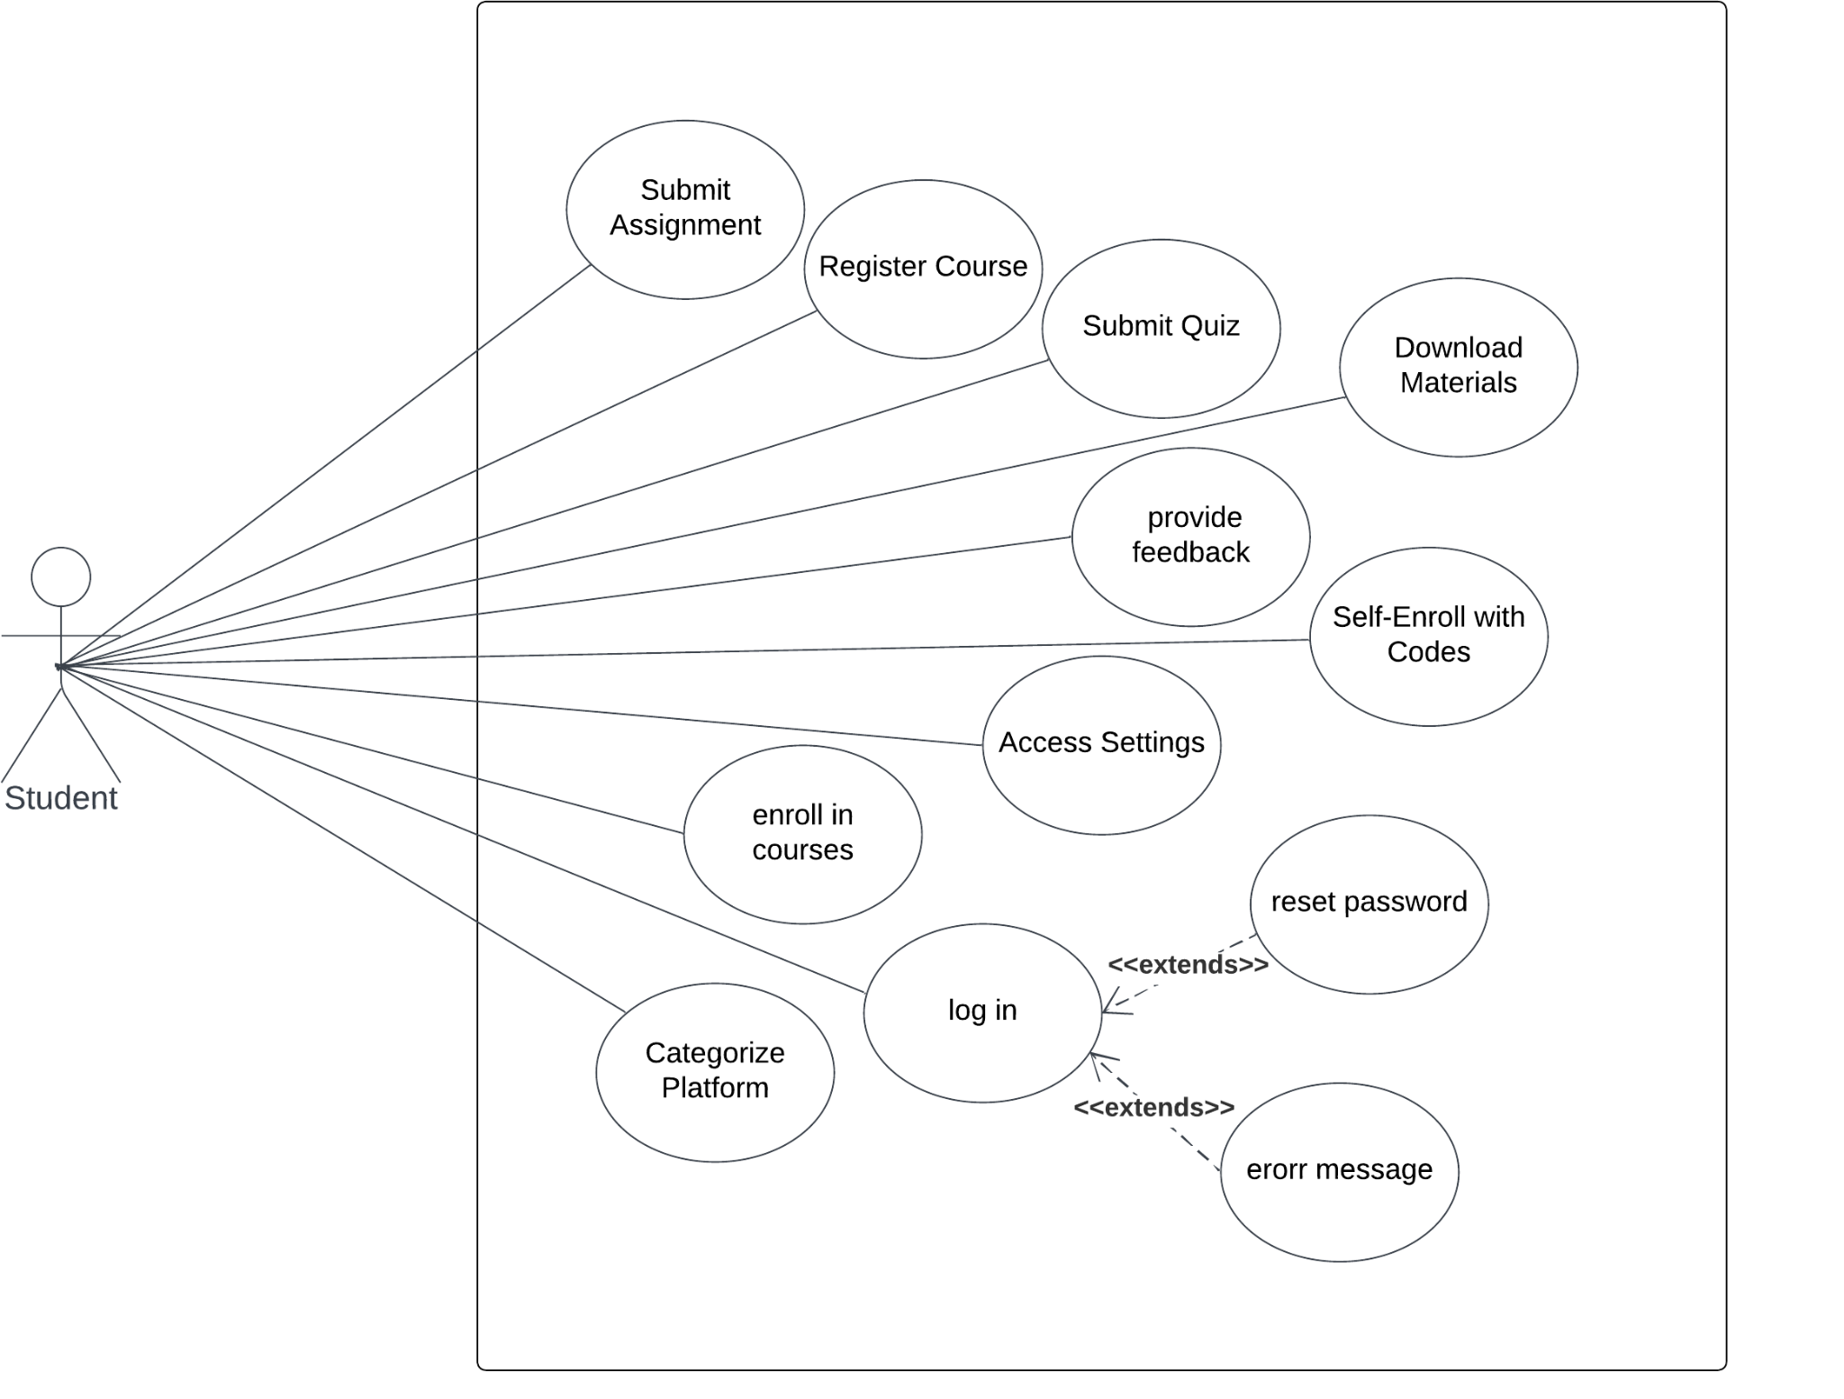

*Figure 2 Student use case Diagram*

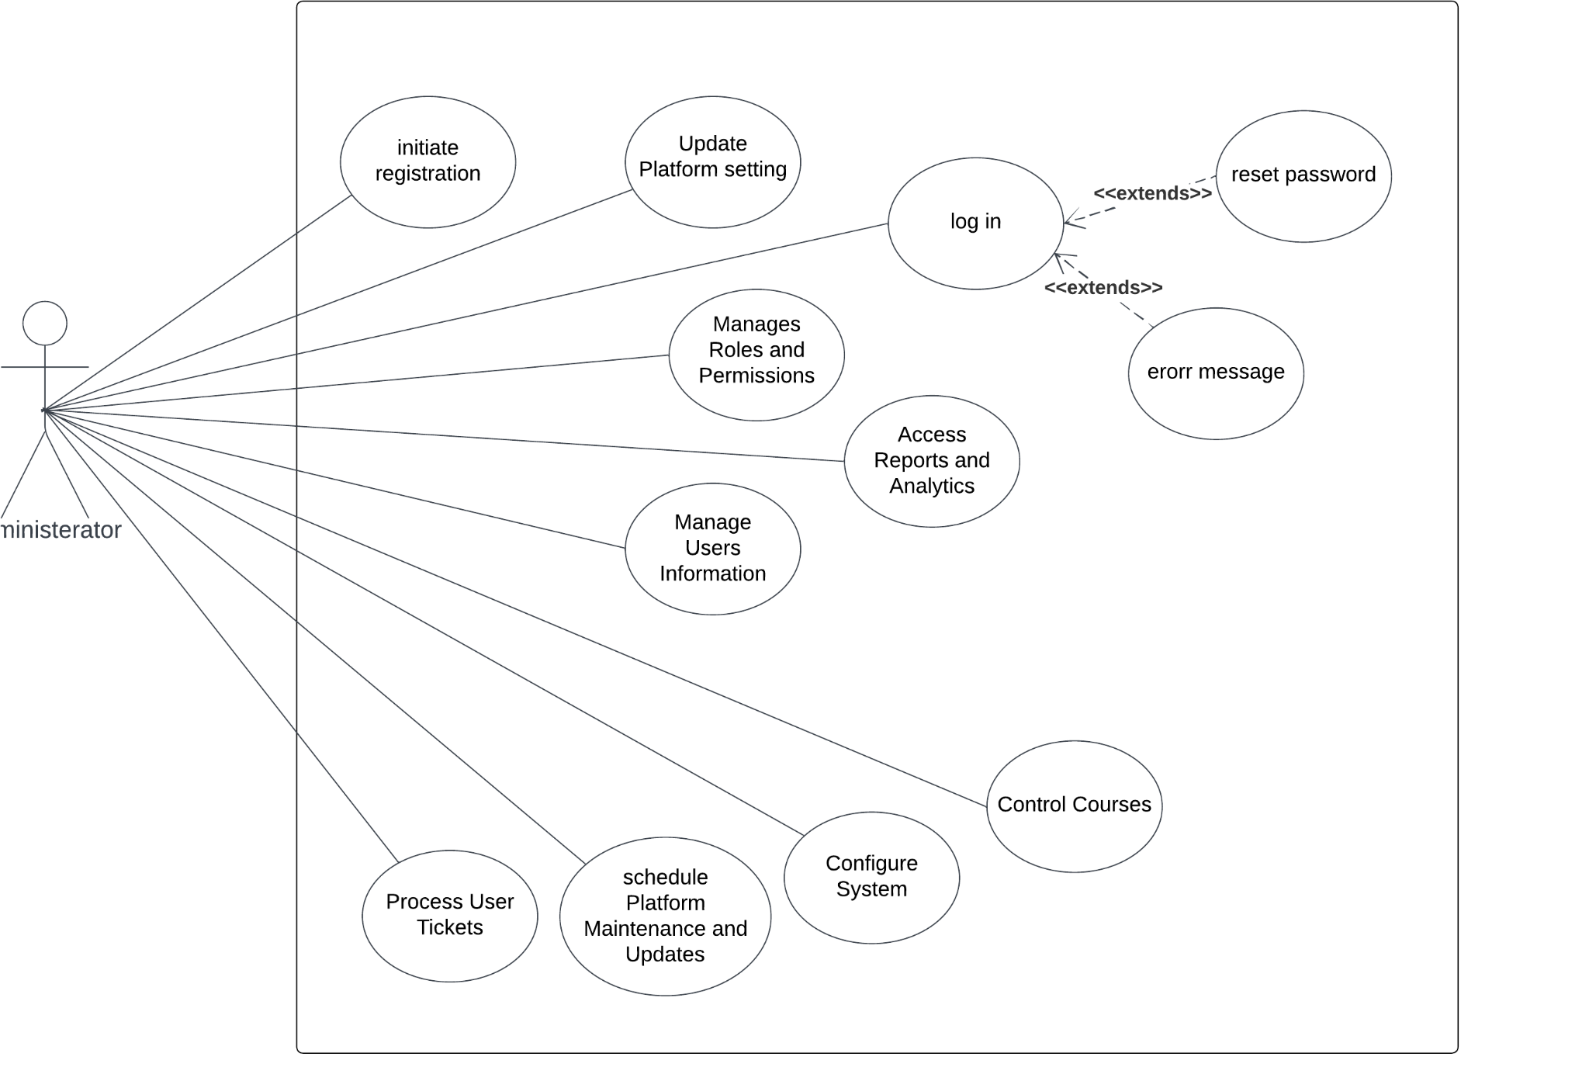

*Figure 3 Administrator use case Diagram.*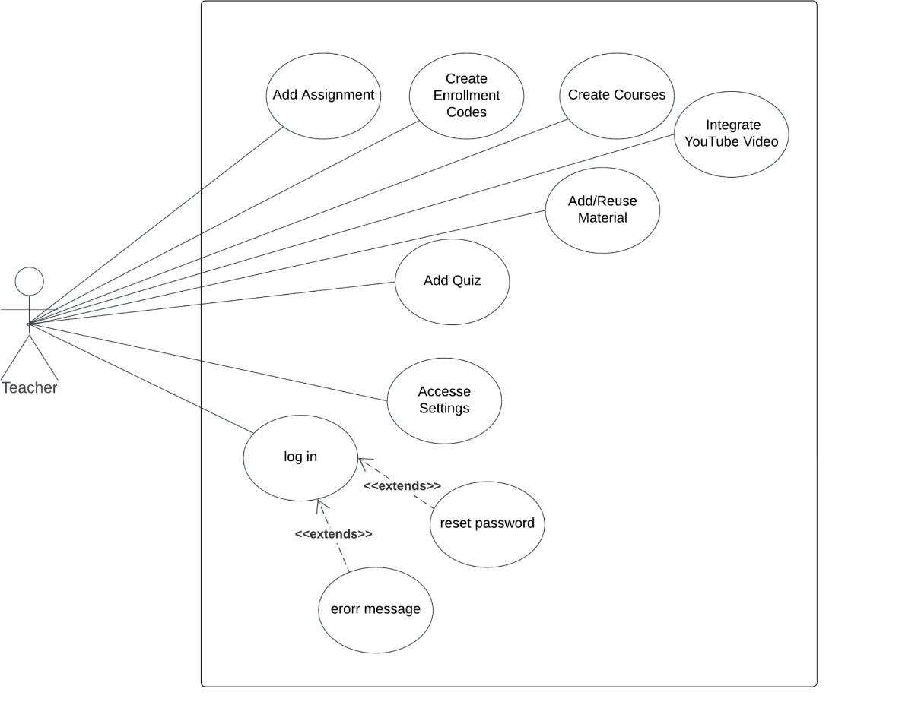

*Figure 4 Teacher use case Diagram*

## 3.7 Use Case Descriptions

**1: User Registers:**

*Table 3 Use Case Description 1*

| Use case ID | Case 1 | |
| --- | --- | --- |
| Use Case Name | User Registration | |
| Actors | Student, teacher, Admin | |
| Pre-condition | None | |
| Post-condition | User is registered and can log in. | |
| Flow of events | User Action | System Action |
| 1. Users enter their username, email, and password. |  |
|  | * 1. System checks the validation of the entered email, ensuring it is in the correct format and not already registered. |
| Exception scenario | Invalid email format or email already registered. | |

**2: User Logins**

*Table 4Use Case Description 2*

| Use case ID | Case 2 | |
| --- | --- | --- |
| Use Case Name | User Login | |
| Actors | Student, teacher, Admin | |
| Pre-condition | Users are registered. | |
| Post-condition | User is logged into the platform. | |
| Flow of events | User Action | System Action |
| 1. User enters their registered email and password. |  |
|  | * 1. System validates the entered credentials. |
| Exception scenario | Invalid login credentials. | |

**3: User Resets Password:**

*Table 5Use Case Description 3*

| Use case ID | Case 3 | |
| --- | --- | --- |
| Use Case Name | Password Reset | |
| Actors | Student, teacher, Admin | |
| Pre-condition | User has a registered account. | |
| Post-condition | User can log in with a new password. | |
| Flow of Events | User Actions | System Actions |
| 1. User enters their email and clicks on the "Forgot Password" link. |  |
|  | * 1. System sends a password reset link to the user's email. |
| 1. User receives the email and clicks on the reset link. |  |
|  | * 1. User is redirected to a page where they can create a new password. |
| 1. User enters a new password and confirms it. |  |
|  | * 1. The system updates the user's password. |
| Exception scenario | Invalid or unregistered email address. | |

**5: Teacher Adds Assignment:**

*Table 6Use Case Description 5*

| Use case ID | Case 5 | |
| --- | --- | --- |
| Use Case Name | Assignment Creation | |
| Actors | Teacher | |
| Pre-condition | Teacher is logged into their account and accesses the course. | |
| Post-condition | Assignment is created and students are notified. | |
| Flow of Events | User Actions | System Actions |
| 1. Teacher provides assignment details, including title, description, and due date. |  |
|  | * 1. The system notifies enrolled students about the new assignment. |
| 1. Teacher creates the assignment. |  |
| Exception scenario | None | |

**6: Student Submits Assignment:**

*Table 7Use Case Description 6*

| Use case ID | Case 6 | |
| --- | --- | --- |
| Use Case Name | Assignment Submission | |
| Actors | Student | |
| Pre-condition | Students are logged into their account and access the course with an assignment. | |
| Post-condition | Assignment submission is recorded. | |
| Flow of Events | User Actions | System Actions |
| 1. Student navigates to the assignment submission section. |  |
| 1. Students upload their assignment file or enter text.   Student submits the assignment. |  |
|  | * 1. The system records the submission and notifies the teacher. |
| Exception scenario | The file size is too big | |

**7: Student Checks Progress:**

*Table 8 Use Case Description 7*

| Use case ID | Case 7 | |
| --- | --- | --- |
| Use Case Name | Progress Tracking | |
| Actors | Student | |
| Pre-condition | Students are logged into their account and access the course. | |
| Post-condition | Students view their course progress. | |
| Flow of Events | User Actions | System Actions |
| 1. Students view the course progress dashboard. |  |
|  | * 1. The system displays completed and pending lectures and tasks. |
| 1. Students can track their progress and navigate to different course sections. |  |
| Exception scenario | None | |

**8: Student Labels and Categorization/Platform Organization:**

*Table 9 Use Case Description 8*

| Use case ID | Case 8 | |
| --- | --- | --- |
| Use Case Name | Content Organization | |
| Actors | Student | |
| Pre-condition | Student is logged into their account and have at least one enrolled course. | |
| Post-condition | Content is organized with clear labels and categories. | |
| Flow of Events | User Actions | System Actions |
|  | 1. The system provides labeling, categorization, and tagging features. |
| 1. User interacts with the content organization features to classify resources. |  |
| Exception scenario | None | |

**9: Teacher Creates Enrollment Codes:**

*Table 10 Use Case Description 9*

| Use case ID | Case 9 | |
| --- | --- | --- |
| Use Case Name | Enrollment Code Creation | |
| Actors | Teacher | |
| Pre-condition | Teacher is logged into their account and accesses the course management section. | |
| Post-condition | Enrollment code is generated and can be shared with potential students. | |
| Flow of Events | User Actions | System Actions |
|  | 1. The system generates an enrollment code for the course. |
| * 1. Teacher shares the enrollment code with potential students through email, messages, or the platform. |  |
| Exception scenario | None | |

**10: Student Self-Enrolls with Codes**

*Table 11 Use Case Description 10*

| Use case ID | Case 10 | |
| --- | --- | --- |
| Use Case Name | Self-Enrollment with Code | |
| Actors | Student | |
| Pre-condition | Students are logged into their account. | |
| Post-condition | Students are successfully enrolled in the course. | |
| Flow of Events | User Actions | System Actions |
| 1. Students enter the enrollment code provided by the teacher. |  |
|  | * 1. System verifies the code's validity and enrolls the student to the course. |
| Exception scenario | Invalid or expired enrollment code. | |

**11: Teacher Creates Courses:**

*Table 12 Use Case Description 11*

| Use case ID | Case 11 | |
| --- | --- | --- |
| Use Case Name | Course Creation | |
| Actors | Teacher | |
| Pre-condition | Teacher is logged into their account. | |
| Post-condition | The course is created and made available to enrolled students. | |
| Flow of Events | User Actions | System Actions |
| 1. Teacher accesses the course creation section. |  |
| 1. Teacher provides course details, including title, description, and course materials. |  |
| 1. Teacher customizes the course structure and settings. |  |
|  | * 1. System creates the course. |
| Exception scenario | None | |

**12: Teacher Adds/Reuses Material**:

*Table 13 Use Case Description 12*

| Use case ID | Case 12 | |
| --- | --- | --- |
| Use Case Name | Material Management | |
| Actors | Teacher | |
| Pre-condition | Teacher is logged into their account and accesses the course materials section. | |
| Post-condition | Course materials are added or reused for the course. | |
| Flow of Events | User Actions | System Actions |
| 1. Teacher uploads course materials (readings, videos, assignments) or reuses previously uploaded materials. |  |
| Exception scenario | None | |

**13: Teacher Adds Quiz:**

*Table 14 Use Case Description 13*

| Use case ID | Case 13 | |
| --- | --- | --- |
| Use Case Name | Quiz Creation | |
| Actors | Teacher | |
| Pre-condition | Teacher is logged into their account and accesses the course where they want to create a quiz. | |
| Post-condition | The quiz is published for students in the course. | |
| Flow of Events | User Actions | System Actions |
|
| 1. Teacher creates a new quiz |  |
|
|  | * 1. The system notifies enrolled students about the new quiz. |
|
| Exception Scenarios | None | |

**14: Student Submits Quiz:**

*Table 15 Use Case Description 14*

| Use case ID | Case 14 | |
| --- | --- | --- |
| Use Case Name | Quiz Submission | |
| Actors | Student | |
| Pre-condition | Students are logged into their account and access the course with a quiz assignment. | |
| Post-condition | Quiz submission is recorded and awaits grading. | |
| Flow of Events | User Actions | System Actions |
| 1. Students take the quiz, answering questions. |  |
| 1. Student submits the quiz. |  |
|  | * 1. The system records the submission and grades it. |
| Exception scenario | None | |

**15: Teacher Integrates YouTube Video**

*Table 16 Use Case Description 15*

| Use case ID | Case 15 | |
| --- | --- | --- |
| Use Case Name | YouTube Video Integration | |
| Actors | Teacher | |
| Pre-condition | Teacher is logged into their account and accesses the course where they want to include a YouTube video. | |
| Post-condition | The YouTube video is added to the course content. | |
| Flow of Events | User Actions | System Actions |
| 1. Teacher pastes the YouTube video link (URL) into the provided field. |  |
|  | * 1. System validates the URL and fetches the video details. |
|  | * 1. System adds the YouTube video in the course content. |
| Exception scenario | Invalid or inaccessible YouTube video URL. | |

**16: User Accesses Profile Settings**

*Table 17 Use Case Description 16*

| Use case ID | Case 16 | |
| --- | --- | --- |
| Use Case Name | Accessing User Settings | |
| Actors | Student, Teacher, Admin | |
| Pre-condition | User is logged into their account. | |
| Post-condition | User's settings are updated as per their preferences. | |
| Flow of Events | User Actions | System Actions |
| 1. User accesses account settings. |  |
| 1. Users customize aspects including profile information, privacy settings, notification preferences, language preferences, theme selection, accessibility settings, security settings, email preferences, and data management. |  |
| 1. Users save their settings. |  |
|  | * 1. System applies changes |
| Exception scenario | None | |

**17: Feedback Mechanisms**

*Table 18 Use Case Description 17*

| Use case ID | Case 17 | |
| --- | --- | --- |
| Use Case Name | Providing Feedback | |
| Actors | Student | |
| Pre-condition | User is logged into their account. | |
| Post-condition | User feedback is collected for improvement. | |
| Flow of Events | User Actions | System Actions |
| 1. Users provide feedback through surveys, ratings, and open forums. |  |
|  | * 1. System records the provided feedback |
| Exception scenario | None | |

**18: Assessment Tools/Teacher Dashboard**

*Table 19 Use Case Description 18*

| Use case ID | Case 18 | |
| --- | --- | --- |
| Use Case Name | Assessment and Dashboard | |
| Actors | Teacher | |
| Pre-condition | Teacher is logged into their account and has access to the course management section. | |
| Post-condition | Teachers can design, administer assessments and manage courses efficiently. | |
| Flow of Events | User Actions | System Actions |
|  | 1. System provides assessment tools, automated grading, feedback mechanisms, course modifications, and course analytics to teachers. |
| * 1. Teacher designs and administers quizzes, assignments, and assessments. |  |
| Exception scenario | None | |

**19: Student Downloads Materials**

*Table 20 Use Case Description 19*

| Use case ID | Case 19 | |
| --- | --- | --- |
| Use Case Name | Downloading Course Materials | |
| Actors | Student | |
| Pre-condition | Students are logged into their account and access the course materials section. | |
| Post-condition | The selected course material is downloaded to the student's device. | |
| Flow of Events | User Actions | System Actions |
| 1. Students navigate to the "Course Materials" or "Resources" section of the course. |  |
| 1. Students locate the specific material they want to download and open it. |  |
| 1. Within the material view, the student finds and clicks on the "Download" button/icon. |  |
| 1. Student selects the download location and confirms the download. |  |
|  | * 1. The system generates the download file. |
| Exception scenario | None | |

**20: Admin Manages Users Information**

*Table 21 Use Case Description 20*

| Use case ID | Case 20 | |
| --- | --- | --- |
| Use Case Name | User Management | |
| Actors | Admin | |
| Pre-condition | Admin is logged into their Admin account. | |
| Post-condition | User accounts are managed according to Admin's actions. | |
| Flow of Events | User Actions | System Actions |
| 1. Admin views a list of all users registered on the platform. |  |
| 1. Admin accesses individual user profiles to view and edit their information. |  |
| 1. Admin resets passwords for users or forces password changes. |  |
| 1. Admin deactivates or suspends user accounts if necessary. |  |
| 1. Admin reactivates previously suspended accounts. |  |
| Exception scenario | None | |

**21: Admin Controls Courses**

*Table 22 Use Case Description 21*

| Use case ID | Case 21 | |
| --- | --- | --- |
| Use Case Name | Course Management | |
| Actors | Admin | |
| Pre-condition | Admin is logged into their Admin account. | |
| Post-condition | Course-related actions are executed according to the Admin's decisions. | |
| Flow of Events | User Actions | System Actions |
| 1. Admin views a list of all courses offered on the platform. |  |
| 1. Admin modifies or deletes courses. |  |
| 1. Admin assigns or changes instructors for courses. |  |
| 1. Admin sets course enrollment limits. |  |
| 1. Admin archives or temporarily hides courses. |  |
| 1. Admin reviews and approves/disapproves course content created by teachers. |  |
| Exception scenario | None | |

**22: Admin Updates Platform setting**

*Table 23 Use Case Description 22*

| Use case ID | Case 22 | |
| --- | --- | --- |
| Use Case Name | Platform Content Management | |
| Actors | Admin | |
| Pre-condition | Admin is logged into their Admin account. | |
| Post-condition | Platform content is managed based on Admin's actions. | |
| Flow of Events | User Actions | System Actions |
| 1. Admin accesses and manages the platform's content repository. |  |
| 1. Admin adds, edits, or deletes platform-level materials (e.g., templates, guidelines, policies). |  |
| 1. Admin restricts access to certain content based on user roles or permissions. |  |
| Exception scenario | None | |

**23: Admin Manages Roles and Permissions**

*Table 24 Use Case Description 23*

| Use case ID | Case 23 | |
| --- | --- | --- |
| Use Case Name | Role and Permission Management | |
| Actors | Admin | |
| Pre-condition | Admin is logged into their Admin account. | |
| Post-condition | User roles and permissions are managed as per the Admin's actions. | |
| Flow of Events | User Actions | System Actions |
| 1. Admin defines and manages user roles and permissions. |  |
| 1. Admin creates custom user roles with specific permissions. |  |
| 1. Admin assigns roles to users or groups of users. |  |
| 1. Admin revokes or modifies permissions for specific users or roles. |  |
| 1. Admin tracks changes to roles and permissions. |  |
| Exception scenario | None | |

**24: Admin Accesses Reports and Analytics**

*Table 25 Use Case Description 24*

| Use case ID | Case 24 | |
| --- | --- | --- |
| Use Case Name | Reports and Analytics Management | |
| Actors | Admin | |
| Pre-condition | Admin is logged into their Admin account. | |
| Post-condition | Admins can make informed decisions based on the insights from reports and analytics. | |
| Flow of Events | User Actions | System Actions |
| 1. Admin accesses comprehensive reports and analytics on user activity, course engagement, and platform usage. |  |
| 1. Admin uses analytics to identify trends, areas for improvement, and potential issues. |  |
| Exception scenario | None | |

**25: Admin configures System**

*Table 26 Use Case Description 25*

| Use case ID | Case 25 | |
| --- | --- | --- |
| Use Case Name | System Configuration Management | |
| Actors | Admin | |
| Pre-condition | Admin is logged into their Admin account. | |
| Post-condition | Platform settings and configurations are adjusted based on Admin's actions. | |
| Flow of Events | User Actions | System Actions |
| 1. Admin configures system settings and parameters according to specific needs. |  |
| 1. Admin sets the default language and accessibility settings for the platform. |  |
| 1. Admin configures email templates and communication settings. |  |
| 1. Admin integrates external tools or services for enhanced functionality. |  |
| Exception scenario | None | |

**26: Admin Processes User Tickets**

*Table 27 Use Case Description 26*

| Use case ID | Case 26 | |
| --- | --- | --- |
| Use Case Name | User Support | |
| Actors | Admin | |
| Pre-condition | Admin is logged into their Admin account. | |
| Post-condition | User inquiries and issues are managed and resolved by the Admin. | |
| Flow of Events | User Actions | System Actions |
| 1. Admin provides support to users by responding to inquiries and troubleshooting issues. |  |
| 1. Admin accesses a support ticketing system to manage and resolve user-reported problems. |  |
| Exception scenario | None | |

**27: Admin schedules Platform Maintenance and Updates**

*Table 28 Use Case Description 27*

| Use case ID | Case 27 | |
| --- | --- | --- |
| Use Case Name | Platform Maintenance and Updates | |
| Actors | Admin | |
| Pre-condition | Admin is logged into their Admin account. | |
| Post-condition | Platform maintenance and updates are executed as scheduled. | |
| Flow of Events | User Actions | System Actions |
| 1. Admin schedules and performs routine maintenance tasks, including updates and backups. |  |
| 1. Admin ensures the platform remains up-to-date with the latest security patches and features. |  |
| Exception scenario | None | |

# 

# Chapter 4: Design

## 4.1 Architecture

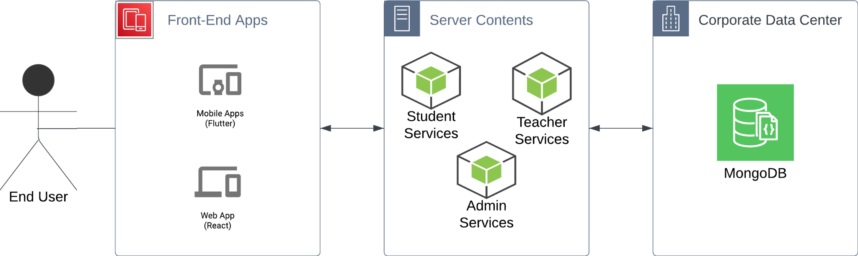

*Figure 5 high-level architecture*

For Academia, the System will be split Into a simple MVC architecture with some minimalistic microservices architecture. The three main modules are independent of each other and are based on XAPI guidelines.

* FrontEnd Applications would have their own hosting server that is independent of the other modules and both simply serve as the interface to receive the data from and manage data that may be on the client side (cookies, downloadable data, uploadable files)
* On the Server The technology utilised will be Node.js Express servers as our objects are JSON-based and databases are document-based, Node.js will provide more functionality and speed to manage our data efficiently. Each stakeholder will have access or their own service which will help separate important computing resources. A teacher would not use their services as much as a student so their services can receive less computing power, while an admin analytical services may cause a big load on the servers.
* The DataBase technology will be MongoDB-based as a NoSQL database will be more suitable for the specification by the XAPI guidelines and allows for easier scalability.

Given the requirements of Academia and the stated above architecture, Special attention should be given to the database schema to save different kinds of files and to specific features like language compatibility and client-side management of files.

## 4.2 BPMN Diagrams

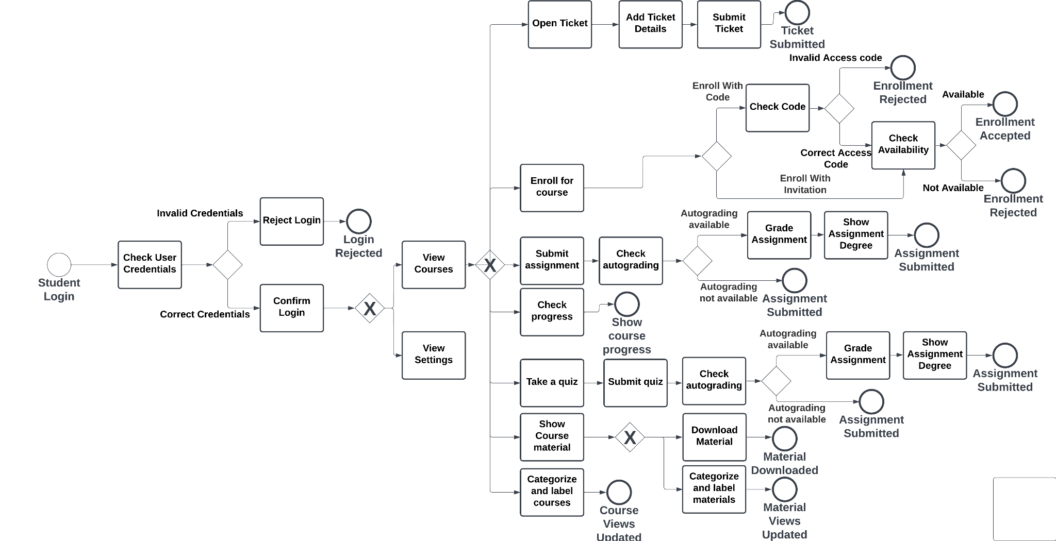

*Figure 6 Student BPMN Diagram*

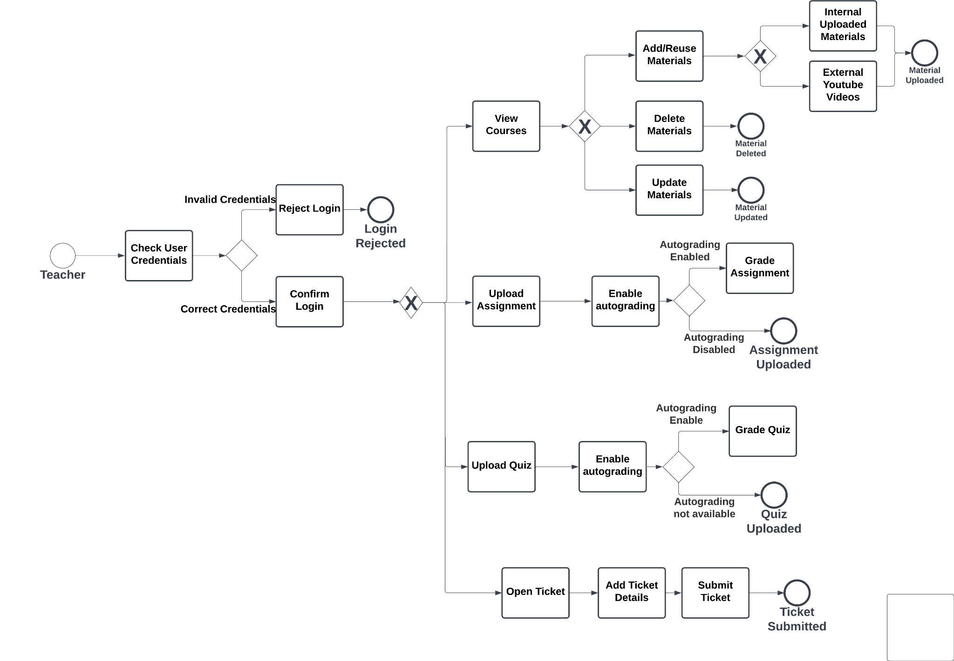

*Figure 7 Teacher BPMN Diagram*

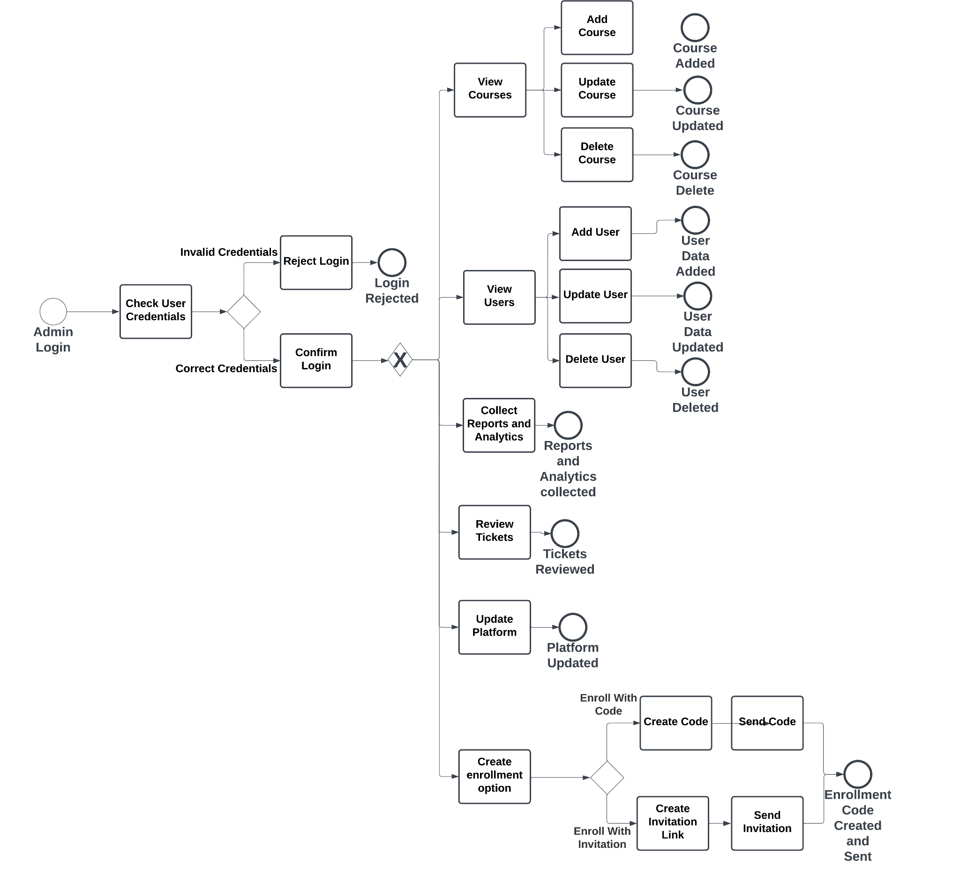

*Figure 8 Admin BPMN Diagram*

# Appendix

## A.Competitor Analysis:

For the full transcript please refer to the Appendix folder attached to this document, a high quality PDF of the analysis table should exist there.

## B. Student Survey:

For the full transcript please refer to the Appendix folder attached to this document, a PDF Form of the survey should exist there.

## C. Teacher Survey:

For the full transcript please refer to the Appendix folder attached to this document, a PDF Form of the survey should exist there.

## D. Responses and data analysis:

For the full transcript please refer to the Appendix folder attached to this document, an excel sheet with the results and analysis steps should exist there.

## E. Students Survey Statistics Results:

Total Participants: 98

General Info “Quantitative”

1. In which language would you like to view the form questions?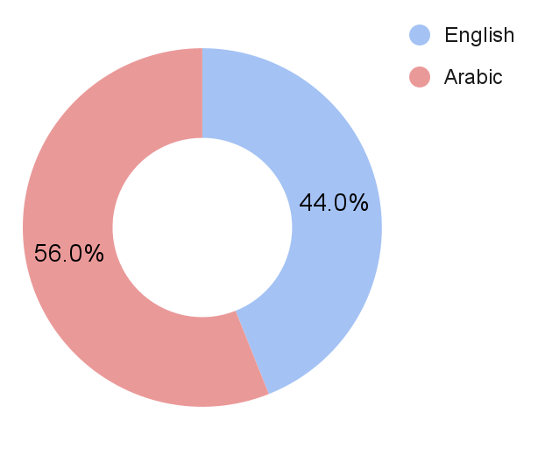
2. What is your current university year?

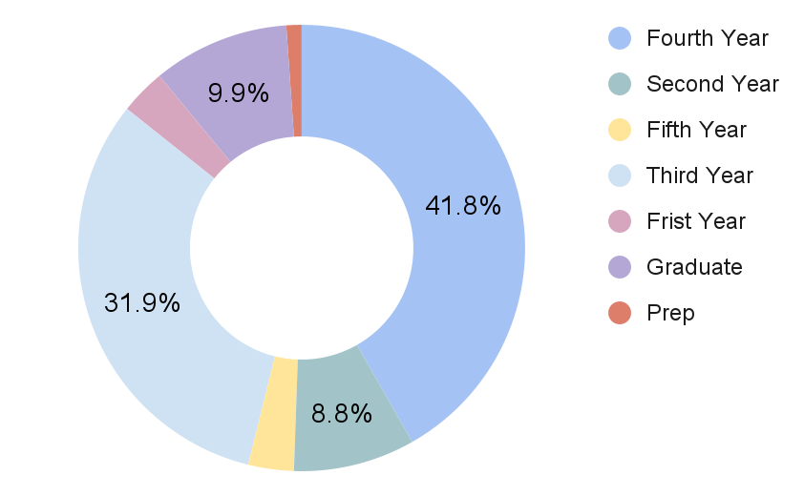

1. What university are you currently attending?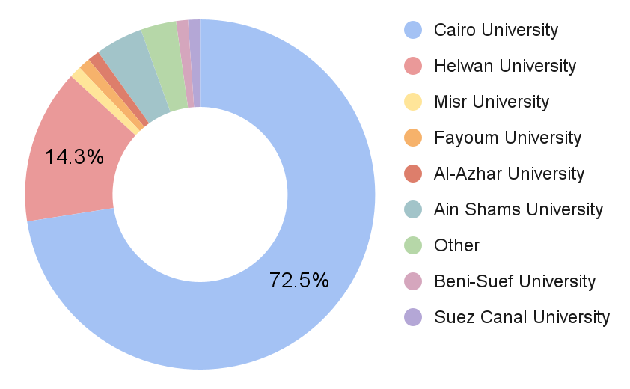
2. What is your faculty or area of study?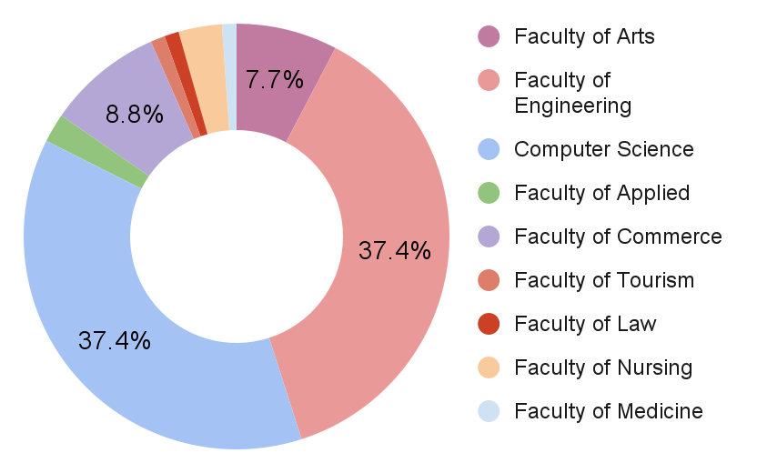
3. Have you ever used any online learning platform during your university studies?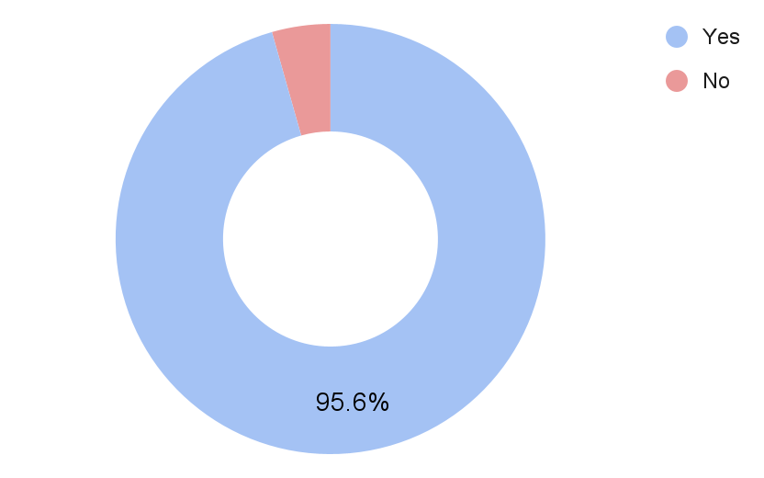

Usage of E-Learning Platforms in Higher Education

1. Please specify the platforms you have used ( you can select multiple platforms based on your personal usage ).

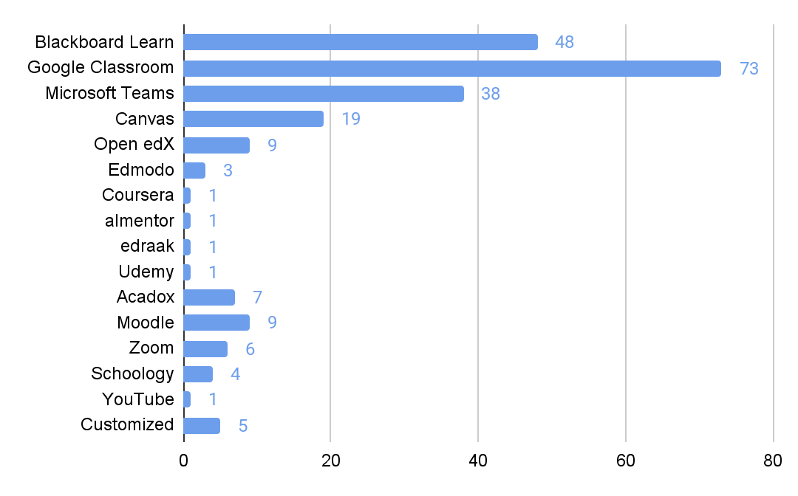

1. Among these platforms, please select the platform that you prefer to use primarily.

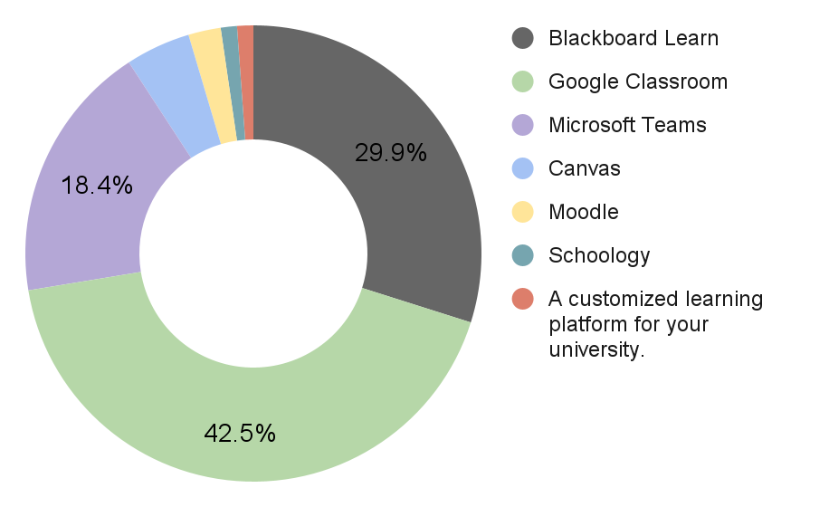

### Blackboard Learn:

1. On a scale of 1 to 10, rate your overall experience with the platform?

* Based on the responses, the ratings range from 4 to 10, with an average rating of approximately 7.8.

1. Could you briefly explain the reason behind your rating choice?

* Based on the provided explanations for the ratings of Blackboard Learn, here is a summary of the reasons behind the rating choices:

Positive aspects:

* Blackboard Learn allows for uninterrupted lectures and provides the option to save recorded lectures.
* The platform is comprehensive and consolidates course content in one place.
* It is user-friendly and easy to navigate.
* It offers features such as meetings, grades, and exams.
* It is stable, easy to use, and has integrated features.
* It helps in organizing educational materials and recorded lectures.
* It saved a significant amount of time and facilitated learning.

Negative aspects:

* The user interface (UI) can be complex or messy for some users.
* There are occasional technical issues during online quizzes.
* Some desired functionalities are missing.
* It may be unavailable or restricted to specific universities.
* It can be clunky or difficult to use at times.
* There were complications with streaming and curriculum collection.

Some students experienced problems during enrollment due to codes or restrictions.

SWOT Analysis for Blackboard Learn:

Strengths:

* Uninterrupted lectures and the option to save recorded lectures.
* Comprehensive platform that consolidates course content in one place.
* User-friendly interface and easy navigation.
* Offers essential features like meetings, grades, and exams.
* Stable, easy to use, and integrated features.
* Aids in organizing educational materials and recorded lectures.
* Saves time and facilitates learning.

Weaknesses:

* Complex or messy user interface for some users.
* Occasional technical issues during online quizzes.
* Missing desired functionalities.
* Limited availability or restrictions to specific universities.

Opportunities:

* Addressing the user interface issues to improve overall user experience.
* Resolving technical glitches and enhancing platform performance.
* Incorporating additional features to meet diverse educational needs.
* Expanding availability to reach a broader user base.

Threats:

* Competition from other e-learning platforms.
* Negative user experiences leading to reduced adoption.
* Technological disruptions impacting platform usability.

1. On a scale of 1 to 5, rate the performance and speed of the platform.

* Based on the responses, the ratings range from 2 to 5, with an average rating of approximately 3.5.

These ratings suggest that the majority of students perceive the performance and speed of the platform as satisfactory, with some room for improvement.

Understanding the user perception of the platform's performance and speed helps in identifying areas that may require optimization to ensure a smoother and more efficient user experience.

1. On a scale of 1 to 5, rate the features/tools available on the platform.

* Based on the responses, the ratings range from 3 to 5, with an average rating of approximately 4.

These ratings indicate that the majority of students perceive the features/tools available on the platform as satisfactory to good.

Understanding the user perception of the available features/tools helps in identifying their effectiveness and areas that may require enhancement or additional functionalities to better support the learning process.

1. On a scale of 1 to 5, rate the user interface of the platform.

* Based on the responses, the ratings range from 2 to 5, with an average rating of approximately 3.7.

These ratings suggest that the user interface of the platform is generally perceived as average to good, with some room for improvement.

Understanding the user perception of the user interface helps in identifying areas that may require enhancement to improve the usability, clarity, and overall user experience.

1. What improvements or changes would you like to see in the platform?

* Based on the responses, here are some common themes:
* Improved communication features: Some users expressed a desire for better communication channels between students, instructors, and administrators, allowing for easier interaction and discussions related to course content.
* Easier navigation and user interface: Several users mentioned the need for a more user-friendly interface, with simplified navigation and a cleaner layout to reduce clutter and enhance the overall user experience.
* Enhanced speed and performance: A few users highlighted the importance of improving the platform's speed and performance, ensuring smooth and efficient usage.
* Accessibility and availability: Some users expressed a desire for the platform to be freely accessible to all users and available for use by everyone, suggesting the importance of inclusivity.
* Clear instructions and tutorials: A few users mentioned the need for clear instructions and tutorials, particularly regarding the registration process, connectivity issues, and how to access and complete assignments.
* Improved video streaming and quality: Some users requested improvements in the quality of online lectures, better video streaming, and enhanced connectivity to ensure a seamless learning experience.

### b. Google Classroom Users

1. On a scale of 1 to 10, rate your overall experience with the platform?

* Based on the responses, the ratings range from 7 and 10, with an average rating of approximately 8.54.

1. Could you briefly explain the reason behind your rating choice?

* Based on the comments, we can identify several reasons behind the rating choices for the overall experience with Google Classroom. Here are the key points:

Positive aspects:

* Ease of use: Users find Google Classroom easy to navigate and utilize without requiring extensive explanation or training.
* Communication: The platform facilitates communication between students and teachers, allowing for messaging and task reminders before deadlines.
* Organization: Users appreciate the organizational features of Google Classroom, such as task tracking, submission dates, and easy access to learning materials.
* Integration with Google Drive: The seamless integration with Google Drive allows for easy access to and storage of learning materials.

Negative aspects:

* Lack of live meetings: Some users mention the absence of live meeting functionality within Google Classroom as a drawback.
* File download limitations: Users note that direct file downloads to their devices are not readily available and require specific methods.
* Communication issues: Some users mention challenges in communication between instructors, indicating that the platform's communication features may need improvement.
* Notification issues: Occasionally, users report issues with notifications not being received promptly or consistently.
* Desired features: Users express a desire for additional features, such as dark theme support, support for quizzes, improved separation between teacher and student posts, and enhanced meeting capabilities.

Overall, the majority of users find Google Classroom easy to use, efficient, and helpful for organizing their academic activities. However, there are suggestions for improvements and the addition of certain features to enhance the platform's functionality.

SWOT Analysis for Google Classroom:

Strengths:

* Ease of use and user-friendly interface.
* Effective communication features between students and teachers.
* Organizational tools for task tracking and submission dates.
* Seamless integration with Google Drive for easy access to learning materials.
* High overall user satisfaction, with an average rating of 8.54 out of 10.

Weaknesses:

* Lack of live meetings functionality within the platform.
* Some users face challenges with file download limitations.
* Communication features may need improvement based on user feedback.
* Occasional notification issues impacting timely updates.

Opportunities:

* Introducing live meeting capabilities to enhance real-time interaction.
* Improving file download processes for a smoother user experience.
* Refining communication features to address user concerns.
* Enhancing notification systems for more reliable and timely updates.
* Adding desired features like dark theme support, support for quizzes, and improved post separation.

Threats:

* Competition from other e-learning platforms offering similar functionalities.
* Potential user dissatisfaction if identified weaknesses are not addressed.
* Technological disruptions affecting platform performance and reliability.

1. On a scale of 1 to 5, rate the performance and speed of the platform.

* The average rating based on the responses is approximately 4.14, indicating a generally positive perception of the platform's performance and speed.

1. On a scale of 1 to 5, rate the features/tools available on the platform.

* Based on the responses, the ratings for the available features and tools range from 1 and 5, with an average rating of approximately 3.77.

1. On a scale of 1 to 5, rate the user interface of the platform.

* Based on the responses, the ratings for the User Interface range from 1 and 5, with an average rating of approximately 3.67.

1. What improvements or changes would you like to see in the platform?

Based on the feedback provided, users have expressed various suggestions and improvements they would like to see in the platform. Some of the common suggestions include:

* Improved Communication: Easier and more direct communication with supervisors or instructors.
* User Interface: Making the interface more user-friendly and familiar, possibly by adopting elements from well-known platforms like Facebook, WhatsApp, or YouTube.
* Better Organization: Implementing clearer organization, such as having organized folders within each course or subject.
* Direct Downloading: Allowing direct downloads similar to Google Drive, without the need to go to another platform.
* Dark Mode: Adding a dark mode option for improved readability and reduced eye strain.
* Enhanced Search Tools: Incorporating additional tools to help users find specific content more easily.
* Online Meetings: Introducing the ability to conduct online meetings within the platform.
* More Features and Settings: Providing more customizable features and settings to tweak the user interface.
* Simplicity and Clarity: Simplifying the platform for better usability and clearer navigation.
* Improved Recordings and Live Sessions: Enhancing the quality and features of recorded lectures and live sessions.

It's important to note that these suggestions come from individual users with their unique perspectives and preferences. Implementing changes to the platform would require careful consideration by the platform's developers, taking into account user feedback and the platform's overall goals and capabilities.

### c. Microsoft Teams Users

1. On a scale of 1 to 10, rate your overall experience with the platform?

* Based on the responses, the ratings range from 7 and 10, with an average rating of approximately 8.54.

1. Could you briefly explain the reason behind your rating choice?

* Based on the comments, we can identify several reasons behind the rating choices for the overall experience with Google Classroom. Here are the key points:

Positive aspects:

* Ease of use: Users find Google Classroom easy to navigate and utilize without requiring extensive explanation or training.

Negative aspects:

* Lack of live meetings: Some users mention the absence of live meeting functionality within Google Classroom as a drawback.

Overall, the majority of users find Google Classroom easy to use, efficient, and helpful for organizing their academic activities. However, there are suggestions for improvements and the addition of certain features to enhance the platform's functionality.

SWOT Analysis for Microsoft Teams:

Strengths:

* Ease of use and user-friendly interface.

Weaknesses:

* Lack of live meetings functionality within the platform.

Opportunities:

* Introducing live meeting capabilities to enhance real-time interaction.

Threats:

* Competition from other e-learning platforms offering similar functionalities.

1. On a scale of 1 to 5, rate the performance and speed of the platform.

* The average rating based on the responses is approximately 4.14, indicating a generally positive perception of the platform's performance and speed.

1. On a scale of 1 to 5, rate the features/tools available on the platform.

* Based on the responses, the ratings for the available features and tools range from 1 and 5, with an average rating of approximately 3.77.

1. On a scale of 1 to 5, rate the user interface of the platform.

* Based on the responses, the ratings for the User Interface range from 1 and 5, with an average rating of approximately 3.67.

1. What improvements or changes would you like to see in the platform?

Based on the feedback provided, users have expressed various suggestions and improvements they would like to see in the platform. Some of the common suggestions include:

* Improved Communication: Easier and more direct communication with supervisors or instructors.

1. On a scale of 1 to 10, rate your overall experience with the platform?

* Based on the responses provided, the ratings for the overall experience with Microsoft Teams platform range from 4 to 10, with an average rating of approximately 7.73.

1. Could you briefly explain the reason behind your rating choice?

* Based on the comments, we can identify several reasons behind the rating choices for the overall experience with Microsoft Teams. Here are the key points:

Positive aspects:

* Easy to use, clear, and simple interface.
* Availability of desired features and easy communication options.
* User-friendly design, easy to understand, and comfortable to work with on both computers and mobile devices.
* Simple platform with no complications.
* Effective meeting quality and chat functionality.
* Organized and straightforward in its approach.
* Good performance without frequent disconnections or interruptions.

Negative aspects:

* Occasional login issues and disruptions in connectivity.
* Some users experienced lags and slow loading times.
* Occasional errors and issues.
* Share screen function not working well, and slow performance at times.
* Internet-related problems causing occasional disruptions.

Overall, Microsoft Teams is praised for its ease of use, user-friendly interface, and effective communication features. However, occasional technical issues and connectivity problems were some of the areas that affected the overall experience for a few users.

SWOT Analysis for Microsoft Teams:

Strengths:

* Easy to use, clear, and simple interface.
* Availability of desired features and easy communication options.
* User-friendly design, comfortable to work with on both computers and mobile devices.
* Organized and straightforward in its approach.
* Effective meeting quality and chat functionality.
* Good performance without frequent disconnections or interruptions.

Weaknesses:

* Occasional login issues and disruptions in connectivity.
* Some users experienced lags and slow loading times.
* Occasional errors and issues.
* Share screen function not working well, and slow performance at times.
* Internet-related problems causing occasional disruptions.

Opportunities:

* Addressing technical issues to improve overall platform stability and performance.
* Implementing UI enhancements based on user feedback to increase usability.
* Optimizing the platform to work efficiently on low-spec devices.
* Improving file upload and download speed and communication during lectures.
* Enhancing video quality and additional functionality like screenshot capabilities.

Threats:

* Competition from other collaboration and communication platforms.
* User dissatisfaction leading to reduced adoption and engagement.
* Technical disruptions impacting platform reliability and user experience.

1. On a scale of 1 to 5, rate the performance and speed of the platform.

* Based on the responses, the ratings for the performance and speed of the platform range from 2 to 5, with an average rating of approximately 3.71.

1. On a scale of 1 to 5, rate the features/tools available on the platform.

* Based on the responses, the ratings for the available features and tools on the platform range from 3 to 5, with an average rating of approximately 4.06.

1. On a scale of 1 to 5, rate the user interface of the platform.

* Based on the responses, the User Interface (UI), the ratings range from 3 to 5, with an average rating of approximately 4.27.

1. What improvements or changes would you like to see in the platform?

Based on the responses, users would like to see the following improvements or changes in the platform:

* Faster speed and improved performance to avoid frequent issues and interruptions.
* Better user interface (UI) with some changes to enhance usability.
* Addressing the problem of slow file upload and download, as well as difficulties in communication during lectures.
* Improvements in video quality and the ability to take screenshots.
* Optimizing the platform to work efficiently on low-spec devices.
* Increased attention to assignments.
* No specific improvements requested by some users.

Overall, users seem to value a smoother and more efficient experience with the platform, focusing on speed, UI enhancements, and better functionality for their learning needs.

1. What is the most important aspect for you when using an e-learning platform?

* Based on the responses provided, the most important aspect when using an e-learning platform seems to be a combination of the following factors:
* Fast and efficient performance: Users prioritize the platform's speed and effectiveness, regardless of its design.
* Ease of design and usability: Users value a platform that is easy to navigate, intuitive, and user-friendly.
* Quick access to frequently used tools: Users appreciate the ability to easily and quickly access the tools and features they frequently use.
* Platform organization: Users prefer a well-organized platform that doesn't necessarily prioritize attractive design over functionality.

These aspects highlight the importance of a smooth user experience, efficient functionality, and convenient access to tools and features. Keep in mind that individual preferences may vary, and different users may have different priorities when it comes to e-learning platforms.

1. What are the aspects that you cannot tolerate in an e-learning platform?

* Based on the responses provided, that are generally not tolerated in an e-learning platform:
* Complex or confusing design that is difficult to understand.
* Slow page loading or connectivity issues.
* Difficulty in uploading files or learning materials.
* Problems with submitting or receiving assignments.
* Issues with viewing recorded lectures.
* Not receiving notifications or updates correctly.
* Login or password reset issues.
* Unclear organization of content or interface.
* Difficulty in communicating with instructors or fellow students.
* Service interruptions or temporary platform downtime.

These are some common aspects that can negatively impact the user experience and hinder effective learning in an e-learning platform.

1. Among the following factors, which aspect do you prefer us to prioritize more in the new platform?

* Based on the responses provided, it appears that the majority of the choices prioritize "Ease of use and quick access to the desired goals" in the new platform. Therefore, it would be advisable to prioritize this aspect to ensure that users can navigate the platform easily and efficiently reach their intended objectives.

1. What are the specific tools you would like to see in the new platform?

* Based on the responses provided, that are generally not tolerated in an e-learning platform:
* Easy access to recorded lectures: A feature that allows users to find and access recorded lectures easily.
* Meeting rooms: Virtual meeting rooms for synchronous learning and collaboration.
* Personalized rooms or spaces: Private spaces where users can gather and organize their learning resources.
* YouTube integration: Integration with YouTube for easy access to external video resources.
* Search functionality: A robust search tool to quickly find specific content or resources within the platform.
* Help or support button: A visible button or feature that provides assistance or guidance to users when needed.
* Screen sharing: The ability to share screens during live sessions or virtual meetings.
* Improved assignment and task submission: Streamlined processes for reviewing, submitting, and receiving assignments and tasks.
* Statistics and analytics: Tools that provide insights and analytics on learning progress and performance.
* User-friendly interface: A visually appealing and intuitive user interface that enhances usability.
* Synced calendar and pace tracker: Integration with a calendar system and automatic tracking of learning progress.
* Messaging and communication features: In-platform chat or messaging capabilities to facilitate communication between students and instructors.
* Note-taking tools: Built-in tools for taking and saving notes within the platform.
* Dark mode: A visual option for a dark-themed interface, which can be easier on the eyes and provide a different aesthetic.
* Feedback and comments: The ability to leave comments, provide feedback, or engage in discussions related to course content.
* File sharing: Easy and efficient ways to share files and documents within the platform.
* Progress indicators: Visual indicators or tracking features to monitor the progress of completing a course.
* Voice call functionality: Easy-to-access voice call capabilities within the platform for communication purposes.
* Group collaboration tools: Features that facilitate collaboration among students, such as group chat or shared workspaces.
* Chatbot support: Integration of chatbot support to provide quick assistance and answer common questions.

These are just some examples of the tools and features that users would like to see in an ideal e-learning platform. The specific requirements may vary depending on individual preferences and needs.

1. How do you imagine the ideal e-learning platform?

* The ideal e-learning platform, based on the responses, would have the following features:
* Ease of use: The platform should be easy to navigate and user-friendly, allowing users to find the necessary materials and features without complications.
* Quick access to content: Users should be able to access recorded lectures and other educational materials at their convenience, without being bound to specific times or schedules.
* Performance and speed: The platform should have fast loading times and a smooth performance to ensure a seamless learning experience.
* Attractive and interactive user interface: An appealing and interactive interface can enhance engagement and make the learning process more enjoyable.
* Availability of features and tools: The platform should provide a variety of tools and features that facilitate learning, such as communication tools, collaboration features, and content creation options.
* Integration with other apps and services: Integration with other apps, such as instant messaging, cloud storage, and calendar applications, can enhance the overall user experience and productivity.

It's important to note that these are general preferences and may vary depending on individual needs and preferences.

## F. Initial Requirements:

Must Have Features:

1. Course progress

* **Description:** enabling learners to monitor their progress by displaying completed and pending lectures and tasks. This feature empowers learners to set goals, celebrate achievements, and stay motivated throughout their learning journey.
* **Vision:** It fosters a sense of accomplishment and accountability among learners. By visualizing their progress, learners are inspired to take ownership of their education, leading to a more structured and fulfilling learning experience.

1. User Dashboard

* **Description:** The user dashboard serves as a centralized hub where learners can access course progress, upcoming tasks, and announcements. Visual representations of achievements and milestones provide learners with a comprehensive overview of their learning journey.
* **Vision:** The user dashboard promotes transparency and accountability. By offering insights into progress and achievements, this feature empowers learners to stay on track and make informed decisions about their studies.

1. Cloud Storage

* **Description:** Cloud storage facilitates seamless access to learning materials from various devices. Learners can effortlessly upload, store, and retrieve files, ensuring their educational resources are easily accessible and organized.
* **Vision:** Cloud storage enhances accessibility and flexibility, enabling learners to engage with content wherever they are. This feature promotes a borderless learning experience, breaking down geographical barriers and accommodating diverse learning styles.

1. Multi-language support ability

* **Description:** we should support multiple languages to allow each student to learn in their language of preferences and change website and application text direction.
* **Vision:** the ease of students.

1. Communication Features

* **Description:** Communication features provide learners with tools to interact with instructors and peers. Real-time messaging, discussion forums, and group chats foster collaborative learning, facilitate knowledge sharing, and strengthen the learning community.
* **Vision:** Communication features create a sense of connectedness among learners. By encouraging active engagement and dialogue, learners can clarify doubts, exchange ideas, and learn from each other, thereby enriching their educational journey.

1. User-Friendly and easy to navigate Interface

* **Description:** A user-friendly interface ensures that the platform is easy to navigate and understand. Intuitive design, clear labels, and organized layout contribute to a positive user experience, minimizing frustration and enhancing engagement. Easy navigation allows learners to quickly access different sections of the platform. Intuitive menus and clear pathways ensure that learners can find their desired content effortlessly, enhancing usability and reducing frustration.
* **Vision:** A user-friendly interface is paramount for an inclusive learning environment. By catering to learners of various technological backgrounds, this feature promotes accessibility and empowers all users to navigate and interact with the platform effectively. Easy navigation is essential to provide learners with a frictionless journey through the platform. By streamlining access to resources, this feature empowers learners to concentrate on their studies rather than struggling with navigation, ultimately promoting efficient learning.

1. Accessible interface

* **Description:** An Accessible LMS is one that encourages and helps people with disabilities to access the learning material and consume like everyone else with as little hurdles as possible. some main features to enable this are “changing font size”, “contrast changer”, “audio alert”, “hot keys”, “sign language interpreter”
* **Vision:** our vision is to allow all kinds of e-learners to be accommodated and learn without hurdles**.**

1. Hot Keys/Quick Access to Tools

* **Description:** Quick access to tools offers learners shortcuts to frequently used features, reducing the time spent searching for resources. This feature optimizes efficiency and encourages learners to focus on their studies without unnecessary delays.
* **Vision:** Quick access to tools enhances productivity, allowing learners to devote more time to active learning. By streamlining workflows, this feature enables learners to engage with content and activities more effectively.

1. Labels and Categorisation/Platform Organization

* **Description:** Platform organization involves categorizing content and resources in a structured manner. Clear labels, nested folders, and efficient tagging systems enable learners to find and access materials with ease**.**
* **Vision:** Platform organization promotes a clutter-free and intuitive learning environment. By reducing information overload and simplifying content discovery, this feature enhances learners' ability to locate and engage with relevant materials.

1. Self Enrollment with invitations or codes

* **Description:** Self-enrollment empowers learners to register for courses independently. This feature grants learner’s autonomy, enabling them to choose courses aligned with their interests and learning goals.
* **Vision:** Self-enrollment fosters a sense of ownership over one's learning journey. By allowing learners to explore subjects of personal interest, this feature encourages motivation and enthusiasm for continuous education.

1. Create Courses

* **Description:** The ability to create courses empowers instructors to design and structure educational content. Customizable course creation tools enable educators to tailor materials to the specific needs and preferences of their learners.
* **Vision:** Course creation tools facilitate pedagogical creativity and customization. By empowering instructors to curate engaging and relevant courses, this feature enhances the quality and diversity of learning experiences.

1. Add Material/Reuse material

* **Description:** The "Add Material" feature allows instructors to upload and share course resources. This feature ensures that learners have access to a variety of content, including readings, videos, assignments, and supplementary materials. and an instructor can also reuse old course material they uploaded before.
* **Vision:** The ability to add material enriches the learning journey with diverse resources. By catering to different learning styles and preferences, this feature promotes comprehensive and well-rounded education.

1. Tasks/Assignments

* **Description:** Task submission enables learners to upload assignments and projects for evaluation. Clear guidelines, user-friendly interfaces, and seamless file uploads streamline the submission process.
* **Vision:** Task submission simplifies the assessment cycle for learners and instructors alike. By providing a convenient platform for submitting work, this feature enhances accountability and facilitates timely feedback.

1. Writing/Post Editor page

* **Description:** a special page allowing teachers and students to create posts with the ability to include pics, text, embed youtube videos, add polls and change fonts.
* **Vision:** giving more customisable to both teacher and student

1. Quiz assignments

* **Description:** allowing teachers to upload quizzes native to the site that allows text, image , multiple options, open ended questions and the choices of automatic grading and manual one.
* **Vision:** Quizzes are a crucial part of education and a teacher should have the ability to create a course and notify students of it.

1. Mobile App Availability

* **Description:** Mobile app availability ensures that learners can access the platform on their smartphones and tablets. Responsive design and optimized functionality enable on-the-go learning, accommodating busy schedules.
* **Vision:** Mobile app availability expands learning opportunities beyond traditional settings. By enabling learners to engage with content anytime, anywhere, this feature facilitates continuous learning and adapts to modern lifestyles.

1. Fast Performance

* **Description:** Fast performance ensures that the platform responds promptly to user interactions. Swift loading times, seamless navigation, and minimal delays contribute to a frustration-free and efficient learning experience.
* **Vision:** Fast performance is essential for maintaining learner engagement and focus. By minimizing waiting times and interruptions, this feature supports a seamless learning flow and enables learners to maximize their study time.

1. Blog per Course

* **Description:** allowing commenting on each teacher post and to allow students to make their own posts in another tab(blog) in each course.
* **Vision:** allow student interaction and encourage a community to help each other.

Should Have Features:

1. Dark Mode Option

* **Description:** A dark mode option provides an alternative color scheme that reduces eye strain in low-light environments. This feature offers a visually comfortable experience for learners who prefer darker interfaces.
* **Vision:** A dark mode option enhances user comfort and accessibility. By promoting a more relaxed viewing experience, this feature accommodates different learning environments and supports extended study sessions.

1. Youtube video Integration

* **Description:** Allow teachers to include youtube embed (iframes in web) to help students through pasting the link into the post.
* **Vision:** Allow teachers to add special resources.

1. SCROM/Xapi/Interopearty Conformance

* **Description:** apply Xapi standards to allow flexibility of data and data sharing between LMS. Those standards are meant to organize your system and processes to help reduce time and data wasted between different students and courses.
* **Vision:** allowing teachers an easier time when creating courses by reusing course materials and allowing sharing of content between different systems.

1. Enhanced Search Tools

* **Description:** Enhanced search tools enable learners to locate specific content quickly. Robust search functionalities, advanced filters, and accurate keyword recognition enhance content discovery and retrieval.
* **Vision:** Enhanced search tools save time and effort by enabling efficient content exploration. By facilitating easy access to resources, this feature supports focused learning and reduces frustration caused by information overload.

1. Customizable Settings

* **Description:** Customizable settings empower learners to personalize their platform experience. Adjustable preferences for themes, layout, notifications, and language ensure that the platform adapts to individual needs.
* **Vision:** Customizable settings cater to diverse learning preferences. By allowing learners to tailor their environment, this feature enhances comfort and satisfaction, fostering a sense of ownership over the learning journey.

1. Direct File Downloads

* **Description:** Direct file downloads allow learners to easily download course materials to their devices. This feature eliminates extra steps and provides convenient offline access to resources.
* **Vision:** Direct file downloads enhance resource accessibility. By enabling learners to save materials for offline viewing, this feature ensures uninterrupted learning even in areas with limited or unstable internet connectivity.

1. Tutorials

* **Description:** use tools like “scribe” to create video tutorials on how to use different website features.
* **Vision:** help students get used to the system and familiarize themselves with it quickly.

1. Improved Notifications

* **Description:** Improved notification systems ensure that learners receive timely updates about assignments, deadlines, and announcements. Customizable preferences and reliable delivery enhance communication and task management.
* **Vision:** Improved notifications keep learners informed and organized. By reducing the risk of missing important information, this feature promotes effective time management and supports proactive learning engagement.

1. Efficient File Management

* **Description:** Efficient file management tools enable learners and instructors to organize, upload, and share resources seamlessly. Intuitive file structures, version control, and easy document management enhance content accessibility.
* **Vision:** Efficient file management simplifies resource sharing and access. By providing a structured and user-friendly file repository, this feature optimizes content distribution and contributes to a well-structured learning environment.

1. Integrated External Resources

* **Description:** Integration with external resources allows learners to access additional learning materials from reputable sources. Links to relevant websites, articles, and multimedia enrich the learning experience with diverse perspectives.
* **Vision:** Integrated external resources broaden the scope of learning. By connecting learners to a wealth of supplementary materials, this feature encourages exploration and critical thinking, enhancing the depth and breadth of knowledge.

1. Assessment Tools/Teacher Dashboard

* **Description:** Assessment tools enable instructors to design and administer quizzes, assignments, and assessments within the platform. Automated grading, feedback mechanisms, and performance analytics streamline the evaluation process.
* **Vision:** Assessment tools facilitate accurate and timely evaluation. By providing instructors with efficient grading and learners with insightful feedback, this feature supports continuous improvement and empowers learners to track their progress.

1. Feedback Mechanisms

* **Description:** Feedback mechanisms enable learners to provide input on courses, content, and the platform itself. Surveys, ratings, and open forums foster learner engagement and empower them to shape their learning environment.
* **Vision:** Feedback mechanisms promote a learner-centered approach. By involving learners in platform improvements and content refinement, this feature enhances user satisfaction and contributes to a continuously evolving learning ecosystem.

1. In-depth Analytics

* **Description:** In-depth analytics provide detailed insights into learner progress, engagement, and performance. Robust data visualization and reporting tools offer instructors and learners a comprehensive view of their learning journey.
* **Vision:** In-depth analytics facilitate informed decision-making. By offering data-driven insights, this feature empowers instructors to tailor interventions, optimize instructional strategies, and personalize learning experiences.

Nice to Have Features:

1. Live Meeting Functionality

* **Description:** Live meeting functionality enables real-time virtual interactions among learners, instructors, and peers. Integrated video conferencing, chat, and collaborative tools facilitate synchronous learning experiences.
* **Vision:** Live meeting functionality enriches collaborative learning. By simulating in-person interactions, this feature fosters dynamic discussions, immediate feedback, and spontaneous knowledge sharing, enhancing engagement and interactivity.

1. Personalized Learning Paths

* **Description:** Personalized learning paths allow learners to customize their curriculum based on their goals, preferences, and skill levels. Adaptive content recommendations and learning roadmaps optimize individual learning trajectories.
* **Vision:** Personalized learning paths cater to diverse learning needs. By tailoring content and pacing to individual requirements, this feature supports self-directed learning and fosters a sense of ownership over the educational journey.

1. Collaborative Features/ Student teams and shared scores

* **Description:** Collaborative features facilitate group work and peer interaction. Shared workspaces, collaborative editing, and group discussions support cooperative learning, enabling learners to collaborate on projects and assignments.
* **Vision:** Collaborative features foster teamwork and knowledge exchange. By encouraging collaborative problem-solving and creative thinking, this feature prepares learners for real-world collaborative scenarios and enhances their interpersonal skills.

## G. Use Cases Brief

For our use cases we opted to make a list of user actions and their description which were used to write the use case diagram and use case descriptions, this appendix entry have the initial use case list, for the developed version with the tabe descriptions please refer to the **Appendix Folder > Analysis Chapter Documents > Use Case Descriptions/Diagram**

1. **User Registers**

* User initiates the registration process by clicking on the "Register" button.
* Users enter their username, email, and password.
* System checks the validation of the entered email, ensuring it is in the correct format and not already registered.
* If the email is already registered:
  + System displays an error message.
  + Users have the option to log in or request a password reset.
* If the email is valid and not registered:
  + System checks the password for complexity and security requirements.
  + User submits the registration form.
  + The system sends an email confirmation request to the provided email address.
  + User receives the confirmation email with a verification link.
  + User clicks on the verification link to confirm their email address.
  + The system validates the link and activates the user's account.
  + User is now registered and can log in.

1. **User Logins**

* User clicks on the "LogIn" button.
* User enters their registered email and password or chooses to log in with Google/Facebook accounts.
* System validates the entered credentials.
* If valid:
  + Users gain access to their account and the platform.
* If invalid:
  + System displays an error message.
  + User has the option to reset the password or contact support.

1. **User Resets Password**

* User clicks on the "Forgot Password" link.
* Users are prompted to enter their registered email address.
* System verifies the email address's existence in the database.
* If the email is valid:
  + System sends a password reset link to the user's email.
  + User receives the email and clicks on the reset link.
  + User is redirected to a page where they can create a new password.
  + User enters a new password and confirms it.
  + The system updates the user's password.
  + Users can now log in with the new password.
* If the email is not valid:
  + System displays an error message.
  + Users are prompted to re-enter their email address.

1. **Student Enrolls in Course**

* Students log into their account.
* Students navigate to the course catalog or search feature.
* Students select a course they want to enroll in.
* System adds the course to the user's enrolled courses.
* If the course is not full:
  + Students can now access the course content.
* If the course is full (maximum enrollment reached):
  + System displays a message indicating that the course is full.
  + Students can join a waiting list if available or choose another course.

1. **Teacher Adds Assignment**

* Teacher logs into their account.
* Teacher accesses the specific course where they are the instructor.
* Teacher navigates to the assignment creation section.
* Teacher provides assignment details, including title, description, and due date.
* Teacher sets assignment parameters, such as maximum points.
* Teacher creates the assignment.
* The system notifies enrolled students about the new assignment.

1. **Student Submits Assignment**

* Students log into their account.
* Students access the course where they have an assignment.
* Student navigates to the assignment submission section.
* Students upload their assignment file or enters text.
* Student submits the assignment.
* The system records the submission and notifies the Teacher.

1. **Student Checks Progress**

* Student logs into their account.
* Student accesses the course.
* Student views the course progress dashboard.
* The system displays completed and pending lectures and tasks.
* Student can track their progress and navigate to different course sections.

1. **Student Labels and Categorization/Platform Organization**

* System must organize content with clear labels, categories, nested folders, and efficient tagging systems for easy resource discovery.

1. **Teacher Creates Enrollment Codes**

* Teacher logs into their account.
* Teacher navigates to the course management section.
* Teacher generates an enrollment code for the course they want to offer.
* Teacher shares the enrollment code with potential students through email, messages, or the platform.

1. **Student Self-Enrolls with Codes**
   * Student receive the enrollment code and logs into their account.
   * Student navigates to the "Enroll in a Course" section.
   * Student enters the enrollment code provided by the teacher.
   * System verifies the code's validity.
   * If the code is valid:
     + Student is successfully enrolled in the course.
     + System adds the course to the student's enrolled courses.
   * If the code is invalid or expired:
     + System displays an error message.
     + Student has the option to re-enter a valid code.
2. **Teacher Creates Courses**

* Teacher logs into their account.
* Teacher accesses the course creation section.
* Teacher provides course details, including title, description, and course materials.
* Teacher customizes the course structure and settings.
* Teacher creates the course.
* The system makes the course available to enrolled students.

1. **Teacher Adds/Reuses Material**

* Teacher logs into their account.
* Teacher navigates to the course materials section.
* Teacher uploads course materials (readings, videos, assignments) or reuses previously uploaded materials.

1. **Teacher Adds Quiz**

* Teacher logs into their account.
* Teacher accesses the course where they want to create a quiz.
* Teacher creates a new quiz with questions, including text, images, multiple-choice, and open-ended questions.
* Teacher configures grading options (automatic or manual).
* Teacher configures the time for the quiz.
* Teacher publishes the quiz for students.
* The system notifies enrolled students about the new quiz.

1. **Student Submits Quiz**

* Student logs into their account.
* Student accesses the course with a quiz assignment.
* Student takes the quiz, answering questions.
* Student submits the quiz.
* System grades the quiz automatically (if configured) or awaits manual grading by the instructor.
* The system records the submission and notifies the Teacher.

1. **Teacher Integrates YouTube Video**

* Teacher logs into their account.
* Teacher accesses the course where they want to include a YouTube video.
* Teacher navigates to the course management section.
* Teacher selects the option to embed a video.
* Teacher pastes the YouTube video link (URL) into the provided field.
* System validates the URL and fetches the video details.
* System adds the YouTube video in the course content.

1. **User Accesses Settings**

* Users can access their account settings by clicking on their profile picture or username.
* Within the user settings section, users can customize various aspects of their platform experience, including:
* **Profile Information:**
* Users can update their profile picture.
* Users can edit their name, bio, or other personal details.
* **Privacy Settings:**
* Users can configure privacy settings for their profile, such as who can view their profile and contact them.
* **Notification Preferences:**
* Users can manage their notification preferences, including email notifications, course updates, and announcements.
* **Language Preferences:**
* Users can select their preferred language for the platform's interface.
* **Theme Selection:**
* Users can choose between different themes (e.g., light mode, dark mode) for the platform's appearance.
* **Accessibility Settings:**
* Users can enable or customize accessibility features, such as text-to-speech or high-contrast mode.
* **Security Settings:**
* Users can update their password or enable two-factor authentication for added security.
* **Email Preferences:**
* Users can specify their email communication preferences, such as newsletter subscriptions.
* **Data Management:**
* Users can access tools to manage their data, including downloading their course materials and personal information.
* Users can save their settings, and the platform will apply the changes accordingly.

1. **Feedback Mechanisms**

* System must allow learners to provide feedback on courses, content, and the platform itself through surveys, ratings, and open forums.

1. **Assessment Tools/Teacher Dashboard**

* System must offer assessment tools for instructors to design and administer quizzes, assignments, and assessments.
* System must provide automated grading, feedback mechanisms, course modifications, and course analytics to teachers.

1. **Student Downloads Materials**

* Students logs into their account.
* Students accesses the course for which they want to download materials.
* Students navigates to the "Course Materials" or "Resources" section of the course.
* Students locates the specific material they want to download (e.g., a document, video, presentation).
* Students clicks on the material to open it.
* Within the material view, user finds a "Download" or "Save" button/icon.
* Students clicks on the "Download" button/icon.
* The system generates the download file.
* Students selects the download location and confirms the download.
* The system initiates the download process.

1. **Admin Manages User**

* The Admin can view a list of all users registered on the platform.
* The Admin can search for specific users based on criteria such as name, email, or role (Teacher, Student, etc.).
* The Admin can access individual user profiles to view and edit their information.
* The Admin can reset passwords for users or force password changes.
* The Admin can deactivate or suspend user accounts if necessary.
* The Admin can reactivate previously suspended accounts.

1. **Admin Manages Courses**

* The Admin can view a list of all courses offered on the platform.
* The Admin can modify or delete courses.
* The Admin can assign or change instructors for courses.
* The Admin can monitor course enrollment and view enrollment statistics.
* The Admin can set course enrollment limits.
* The Admin can archive or temporarily hide courses.
* The Admin can review and approve/disapprove course content created by teachers.

1. **Admin Manages Platform**

* The Admin can access and manage the platform's content repository.
* The Admin can add, edit, or delete platform level materials (e.g., templates, guidelines, policies).
* The Admin can restrict access to certain content based on user roles or permissions.

1. **Admin Manages Roles and Permissions**

* The Admin can define and manage user roles and permissions.
* The Admin can create custom user roles with specific permissions.
* The Admin can assign roles to users or groups of users.
* The Admin can revoke or modify permissions for specific users or roles.
* The Admin can track changes to roles and permissions.

1. **Admin Manages Reports and Analytics**

* The Admin can access comprehensive reports and analytics on user activity, course engagement, and platform usage.
* The Admin can use analytics to identify trends, areas for improvement, and potential issues.

1. **Admin Manages System Configuration**

* The Admin can configure system settings and parameters of the platform according to specific needs.
* The Admin can set default language and accessibility settings for the platform.
* The Admin can configure email templates and communication settings.
* The Admin can integrate external tools or services for enhanced functionality.

1. **Admin Supports User**

* The Admin can provide support to users, including responding to inquiries and troubleshooting issues.
* The Admin can access a support ticketing system to manage and resolve user-reported problems.

1. **Admin Manages Platform Maintenance and Updates**

* The Admin can schedule and perform routine maintenance tasks, including updates and backups.
* The Admin can ensure the platform remains up-to-date with the latest security patches and features.